Requesting IT Hardware

Objective: To provide CSU East Bay, San Francisco State University, and Sonoma State University employees with the business process for requesting IT hardware through the CSUBuy (P2P).

Scope: To assist customers with purchasing IT related hardware and submitting the requisition in the P2P.

(Ctrl + Left Click to select a step below)

P2P (CSUBuy) IT Hardware Requisition - Quick Checklist 1
Before you begin: 1
In P2P (Quick Steps) 1
Roles and responsibilities 2
Common terms: 4
Common compliance documents: 4
Step 1: Accessing the P2P 5
Step 2: Create the requisition in P2P 6
Step 3: Review or print your requisition 21
Step 4: Add comments and attachments 26
Step 5: Submit and track your requisition 33
Troubleshooting and common issues 40
FAQ 40

P2P (CSUBuy) IT Hardware Requisition - Quick Checklist

Before you begin:
- Have your item details ready (model, specs, quantity).
- Have a Supplier quote.
- Have accessibility/security docs if required (VPAT/ACR, HECVAT, COI, etc.).
- Know your chartfields: Fund, Department ID, Account.

In P2P (Quick Steps)
- To access the Procure to Pay portal, open your browser and copy and paste the following link:
  - Click on the CSUBuy/P2P link https://www.sfbrn.calstate.edu/csubuy-p2p.

- Select IT / Electronics > IT Hardware Request.
- If you do not know the supplier, use “Supplier Not Known.”
- On IT Hardware Cost Details, upload quotes and required documentation.
- Add to cart and select delivery location (RECEIVING_CMP for tangible items).
- Proceed to checkout and enter chartfields (Fund, Department ID, Business Unit).

- Add comments/attachments as needed, then submit the request.
- Save your requisition number and check status under Requisitions.
- Reminder: Add a second, non-taxable line for e-waste when purchasing a device with a display screen.
Please refer to the amounts listed below:
  - 4 inches to under 15 inches: $4.00
  - 15 inches to under 35 inches: $5.00
  - 35 inches or greater: $6.00

Roles and responsibilities
Role | What they do
Customer (Requester)  Business Operations | Creates and submits a requisition in P2P. Provides supporting documentation and chartfields.  Provides recommendations; helps obtain quotes; supports supplier onboarding; tracks receipt, delivery, and deployment; supports invoice reconciliation.
Delegation of Authority (DOA) approver:  IT Review:  Security Review  Buyer:  Accounts Payable Technician | Reviews the requisition, comments, chartfields and attachments then approve the request.  Review of IT-related requests to confirm that the requested items can be supported by IT staff and comply with campus standards for computing devices.  Evaluates a supplier’s technology, data practices, and safeguards to ensure university information is appropriately protected from unauthorized access, loss, or security threats.  Review requisition details, negotiate terms and conditions, obtain necessary forms or other documentation (if applicable), and source requisitions into purchase orders.. Dispatch the purchase order to the supplier.  Review invoices, forwards invoices to department DOA for approval, create a voucher, and issues of payment to supplier.

Common terms:
- CSUBuy/P2P: The Procure-to-Pay system used to create and submit a requisition.
- Requisition: A requisition is a formal request for something, usually goods, services, or resources.
- Requisition number: The number used to track your request in the P2P system.
- Purchase Order: A purchase order is a formal document issued by a buyer to a seller authorizing a purchase of specified goods or services at agreed terms.
- Receipt: A receipt is a written acknowledgment confirming that goods/services have been received.
- Voucher: A voucher is an internal document used to authorize and verify a payment before it is issued.
- Invoice: An invoice is a bill sent by a supplier to Accounts Payable requesting payment for goods or services provided.
- Request for Proposal/RFP: Is a formal business document released to announce a project and invite potential vendors or contractors to submit a competitive bid.

Common compliance documents:

- VPAT: Voluntary Product Accessibility Template
A standardized document used by vendors to describe how their product or service supports accessibility standards such as Section 508 of the Rehabilitation Act. It helps organizations evaluate the accessibility compliance of technology products and the impact it will have on their campus.

- ACR: Accessibility Conformance Report.
A completed VPAT form that details a product's conformance with accessibility guidelines. The ACR provides transparency into how accessible a digital product is and identifies any known limitations.

- HECVAT: Higher Education Community Vendor Assessment Toolkit
A comprehensive questionnaire designed to evaluate the cybersecurity and data privacy practices of third-party vendors that provide services to higher education institutions. It helps institutions make informed decisions about vendor risk.

Step 1: Accessing the P2P
- Customers can begin their IT hardware request by navigating to the SFBRN website https://www.sfbrn.calstate.edu/csubuy-p2p:

- Click the CSUBuy Login Button. Customers will login using their campus user login and password.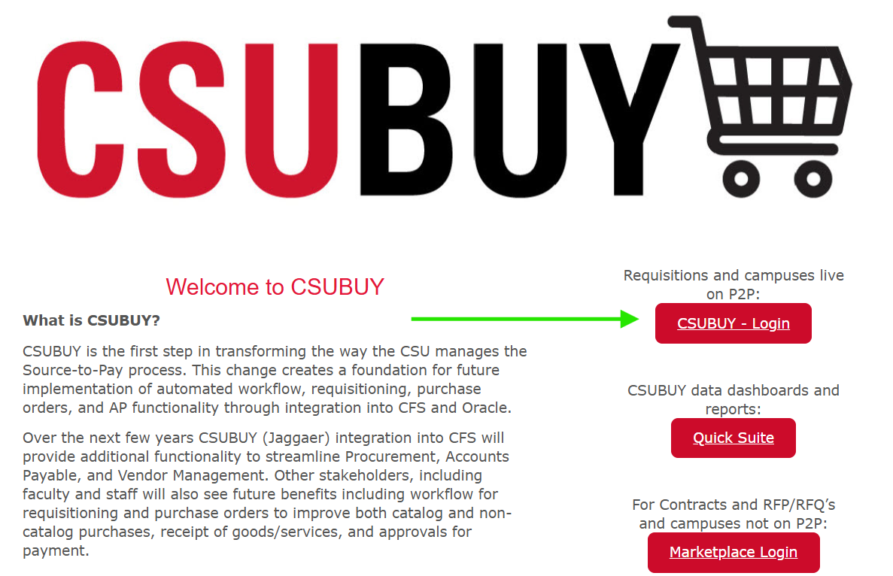

Step 2: Create the requisition in P2P
- After you log in, you will be directed to the CSUBuy Portal Shopping Home Page.
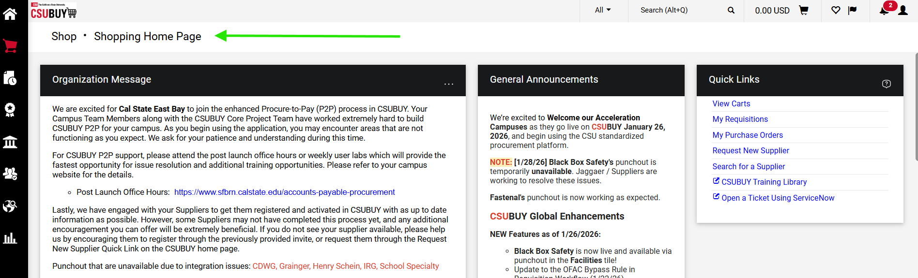

- If you do not see the Shopping Home Page, click the shopping cart icon in the left-hand navigation panel.

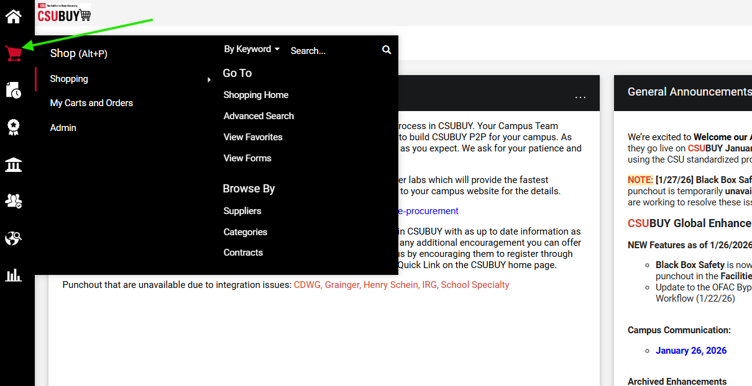
- Scroll down and select the "IT / Electronics" catalog tile.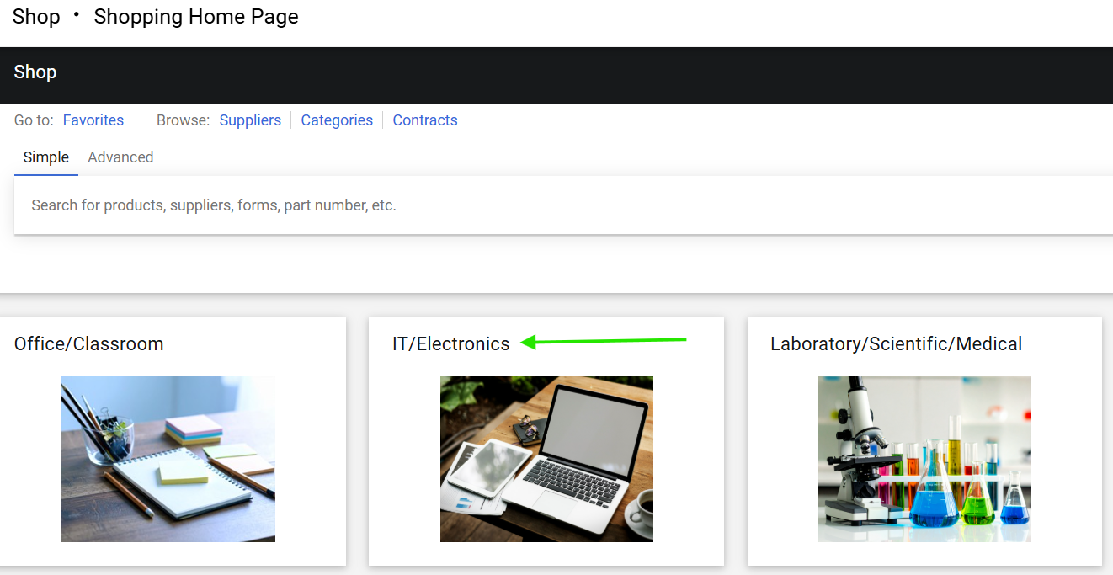
- Select the "IT Hardware Request" catalog item.
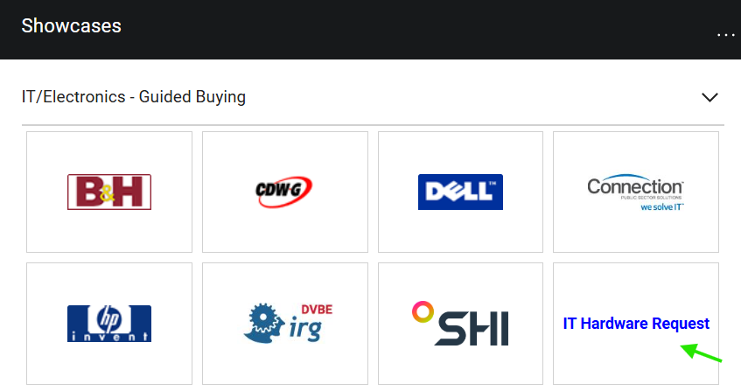

- Review the instructions and click "Next" at the top of the screen.
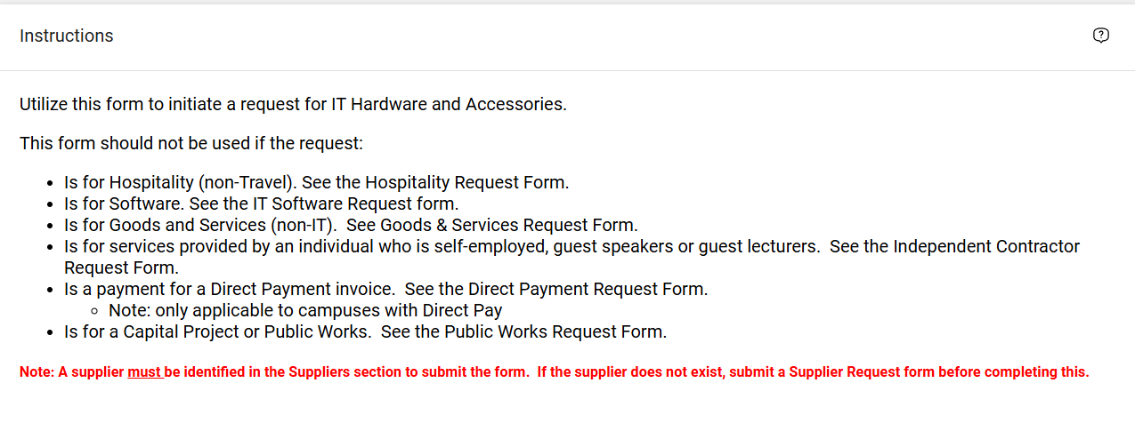

- In the Supplier field, enter the supplier’s name, and click search.
- Check the supplier's name in the results and click “Select” to apply the supplier to the cart.
- If the supplier is unknown, enter “Supplier Not Known,” click Search, and select the “Supplier Not Known” option from the list.
Q: When should we use “Supplier Not Known”?
A: Select “Supplier Not Known” when creating a requisition in the following situations:
- $0 requisition for an RFP: When a supplier has not yet been selected and the requisition is being submitted as part of the RFP process.
- $0 requisition for IT review/approval only: When the requisition is being submitted for an IT, accessibility, or security review and is not yet a purchase request.
- Buyer’s P-Card purchase: When requesting that the Buyer make an approved purchase using their P-Card.
Important: “Supplier Not Known” should only be used for approved situations where the actual supplier cannot or should not be selected when the requisition is created.

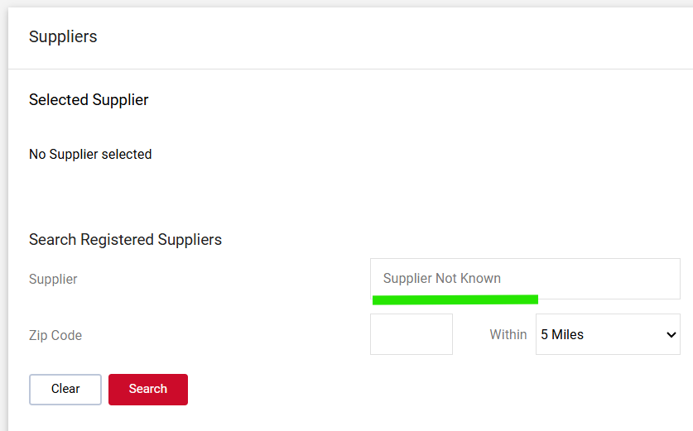

- With "Supplier Not Known" selected, click "Next" at the top right.

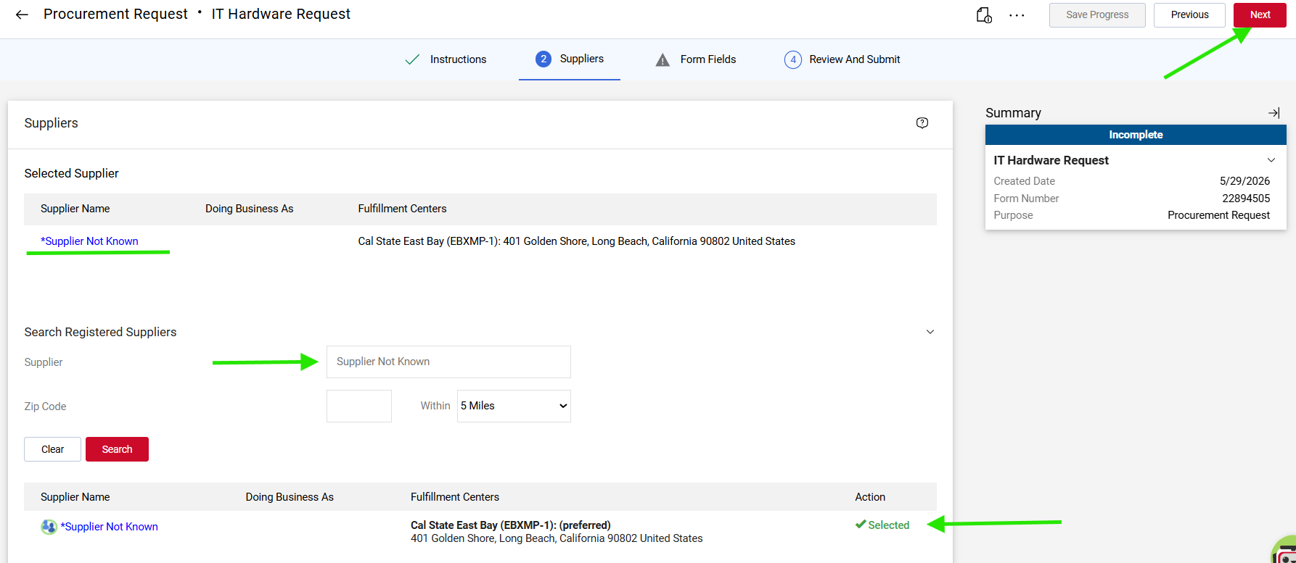

- Complete required fields on the "Products or Services Details" page.
  - Request Type
    - Example: New purchase, renewal, upgrade, replacement, subscription, etc.
  - Name of IT Product
    - Example: Microsoft 365, Adobe Acrobat Pro, Slack, Dell laptop, ServiceNow module, etc.
  - IT Request Number/ITPR
    - Enter the ITPR provided by your campus. (ITPR applies to SFSU only)
    - If you don’t have one yet, select no.
  - IT Product Type
    - Examples: Laptop, Server, Tablet, Smartphone, Monitor, Keyboard, Mouse, Docking station, Printer, External hard drive, Solid-state drive (SSD), Hard disk drive (HDD), Network switch, Router, Firewall appliance, Wireless access point, Graphics card (GPU), Memory (RAM modules), CPU (processor), Motherboard, Power supply unit (PSU), UPS (uninterruptible power supply), Webcam, Headset, Microphone, Speakers, Projector, Barcode scanner, Docking hub, NAS (network-attached storage) device
  - Provide the details and/or justification of the request
    - Explain: What the product is for, why you need it, what problem it solves or what capability it adds, and who will it be using the product.
      - ️ If this is longer than 2,000 characters: Write: “See Attached”
      - Upload full justification as a separate document.
  - List alternative product options that were considered and why those alternatives were rejected.
      - Example: Google Workspace was considered but rejected due to lack of required compliance features.
      - If none, enter “N/A”
  - Does the product include either a standard or an extended warranty?
      - Specify: Standard or Extended warranty
  - Is training required to implement or use the product?
      - Yes/No
  - Provide any available supplier links for product details, technical details or accessibility information.
  - Click the next button in the upper right corner when you’re finished.

- On the "IT Hardware Cost Details" page, fill out all fields.
- Check Yes to attach other supporting documents (e.g., Terms and Conditions, Insurance Certificates, Statement/Scope of Work (SOW), proposals, etc.).
- The uploading of the documents will be available during the Requisition stage.
- If a combo of hardware and services UOM should be LOT and Qty 1 and the Requisition should be marked as an amount only/blanket
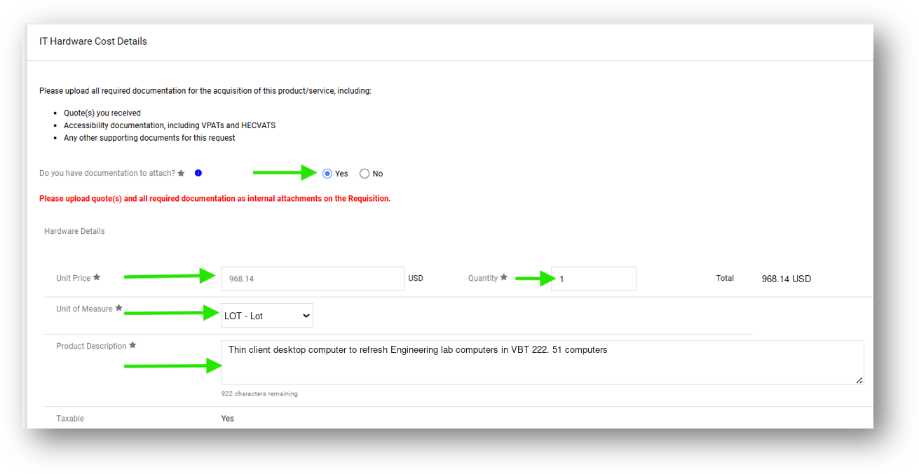
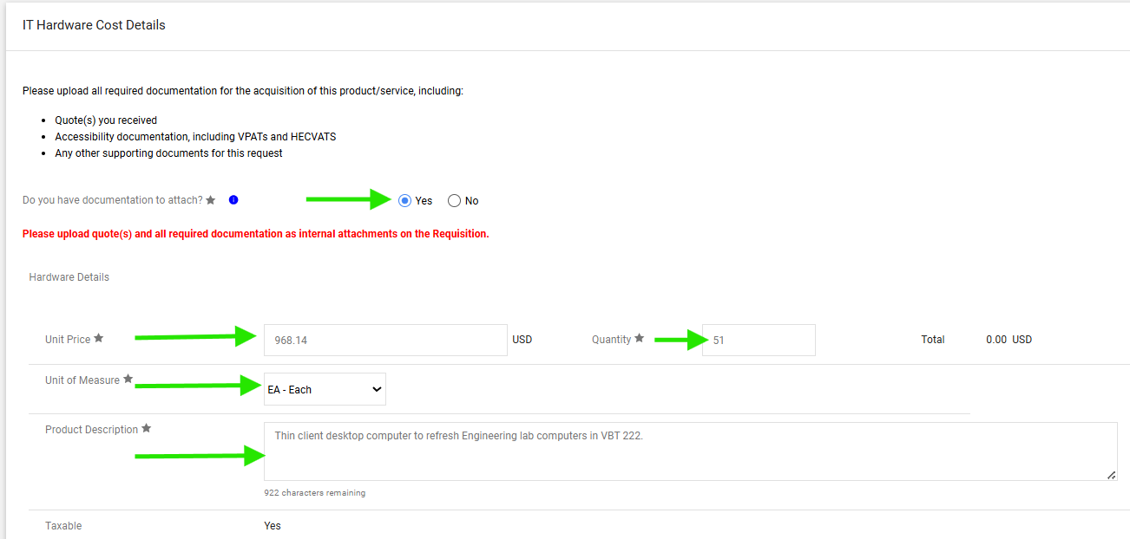
On the "Review and Submit" page, verify supplier and form details.
Click "Add and Go to Cart."
If you need to create a multi-line Requisition, go to add another line by choosing the “Save and Add Another”

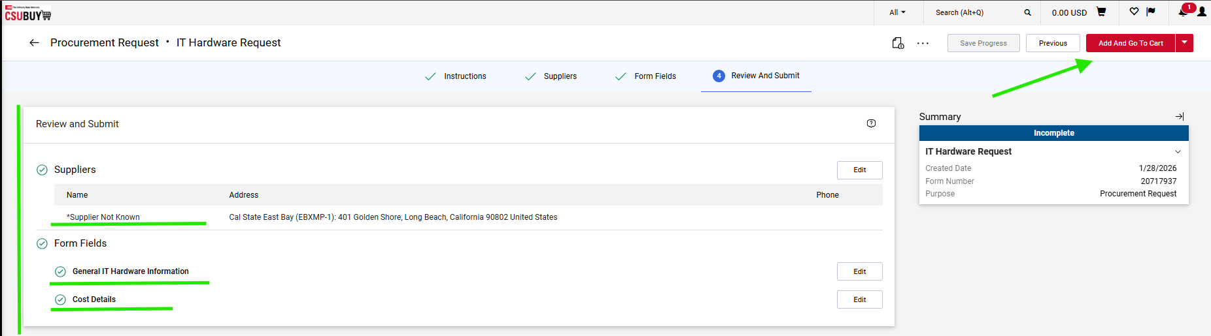

- In the Shopping Cart, select the delivery location.
- For tangible items, search for "RECEIVING" and select the correct delivery location.
- Click the "Proceed Checkout" button.

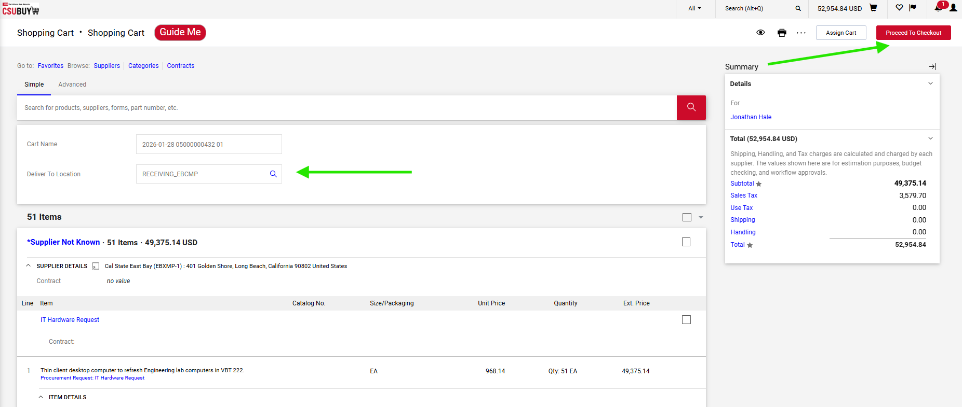

- A requisition number has now been generated by the system.
  - On the Summary Page, confirm the system-generated requisition number.
- Edit the General Information, Address, and PO Information sections using the pencil icons in the upper right corner of each section. (⚠️ Make sure to always leave the Accounting Date blank. ⚠️)
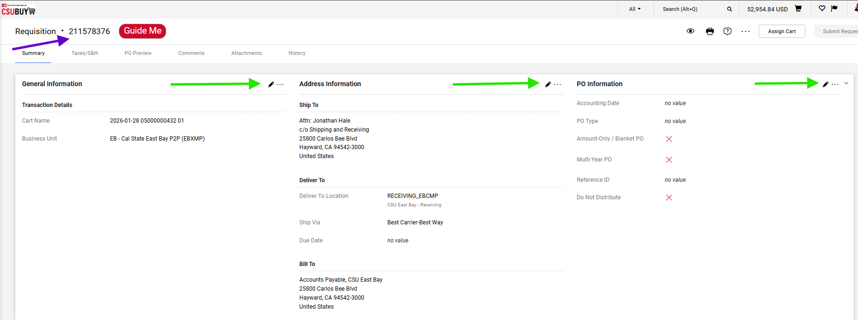

- Scroll down to the bottom of the page and review the “Item Details” and “Chartfields” sections.
Click on the pencil icon to the right of the screen to edit values.
- Is receiving Required
- What is the correct Tax rate
- Is it a Asset
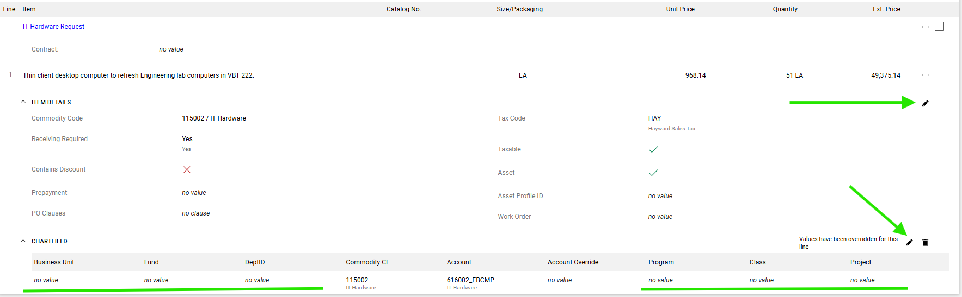

- Enter values in the following fields:
- Required: Fund, Department ID, and Business Unit
- Optional: Program, Class, and Project codes
Click Save.

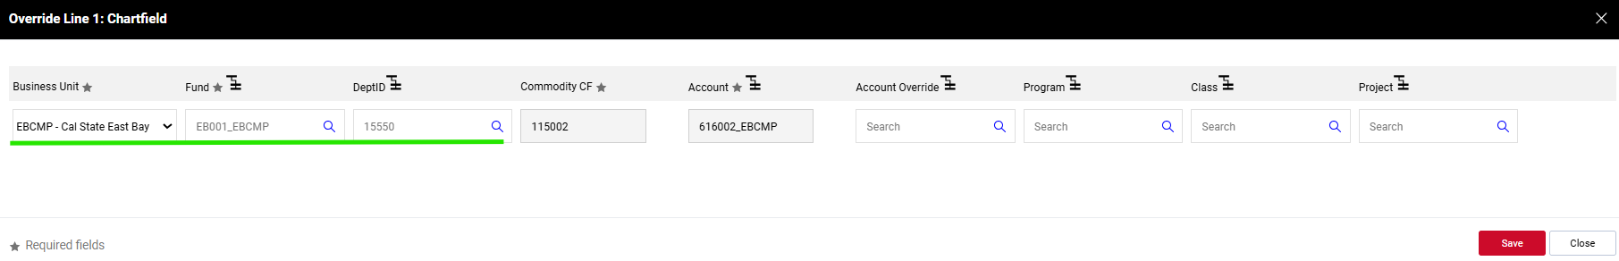

Step 3: Review or print your requisition
- If you would like to view or print a copy of the requisition, click the printer icon in the top right corner of the page.
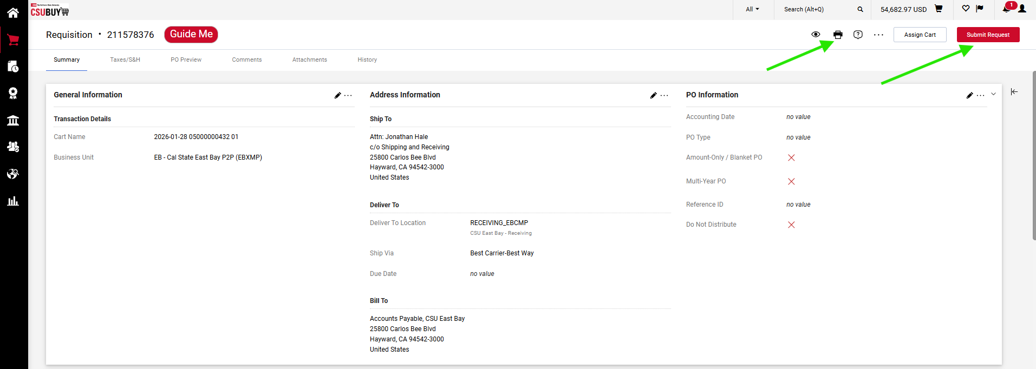

- After clicking the printer icon, you will be redirected to a new page displaying a copy of your requisition.
Click the “Print” button in the top right corner of the page to print or save the document.

- In the print dialog box, select “Save as PDF” to save the requisition to your computer.
Click “Save”.
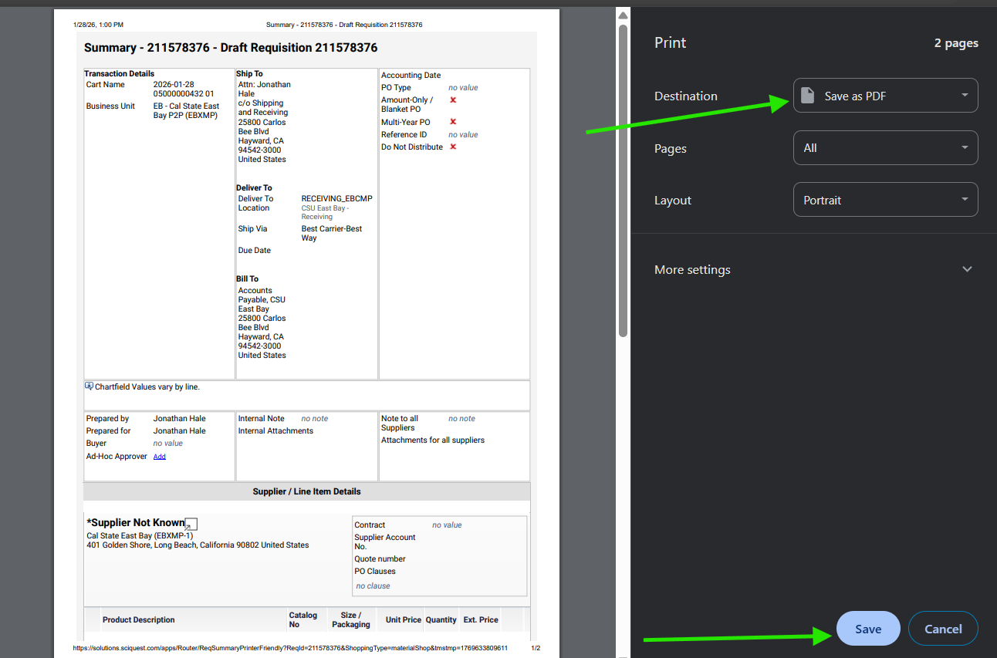

- Select a destination folder.
Enter a file name.
Click save.
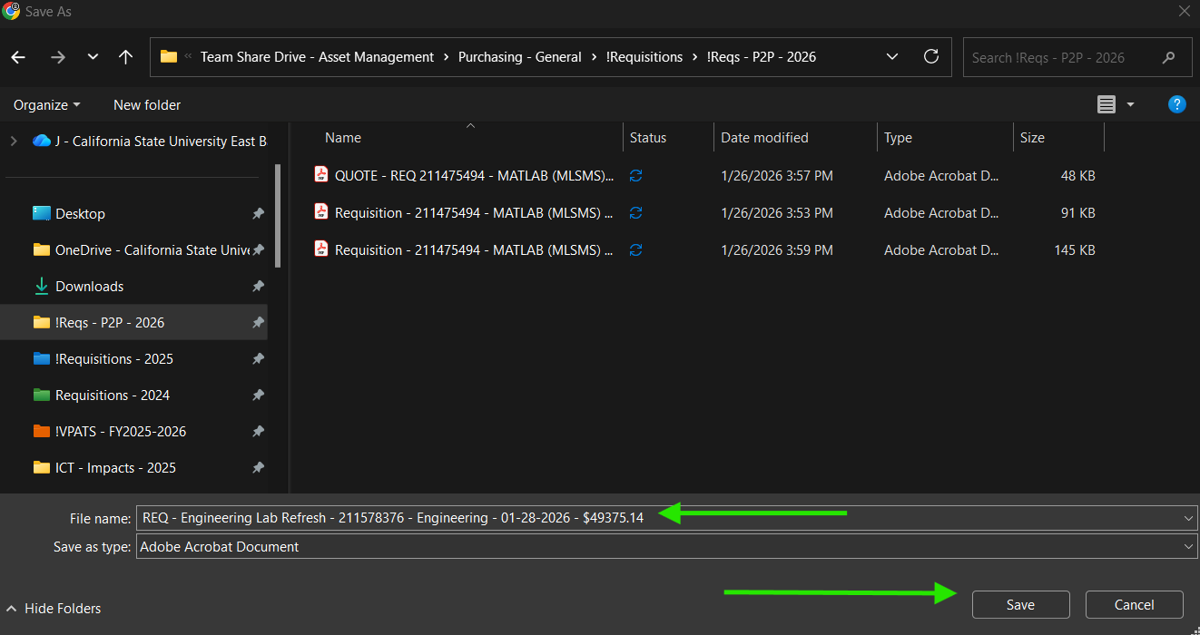

- The print dialogue screen will close and you will be returned to the requisition print summary page.
Click the "Close" button at the top right corner of the screen to exit this page.

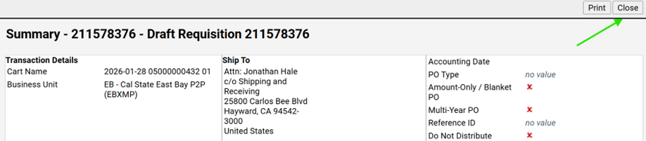

- On the Requisition Summary page, you can add comments and attach additional documents.

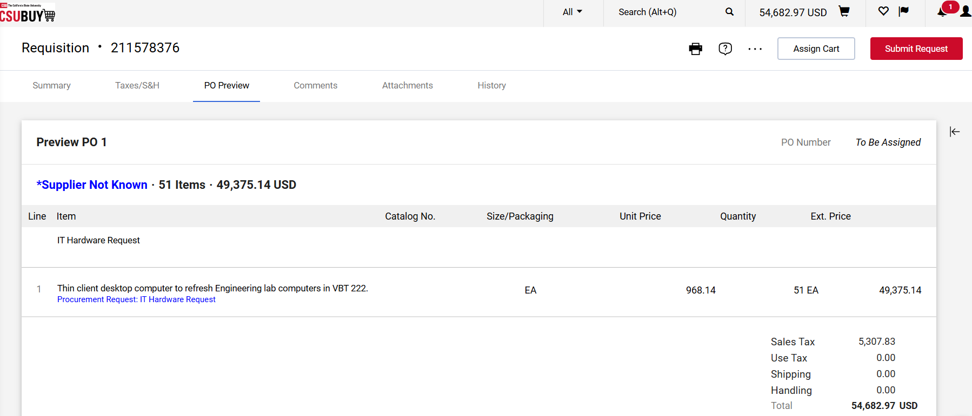

Step 4: Add comments and attachments

- Add internal comments by clicking on the Comments tab.
Select a comment type and click the "+" icon.
Then select your comment type from the drop-down menu and click the “+” icon.

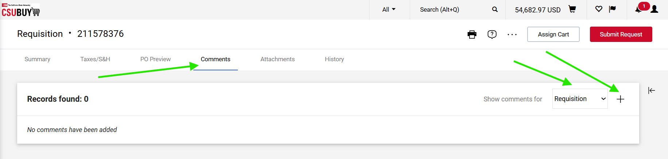
- Enter comments in the comment field.
To attach a file, click "Choose File", select your file, then click the "✔" icon to save.
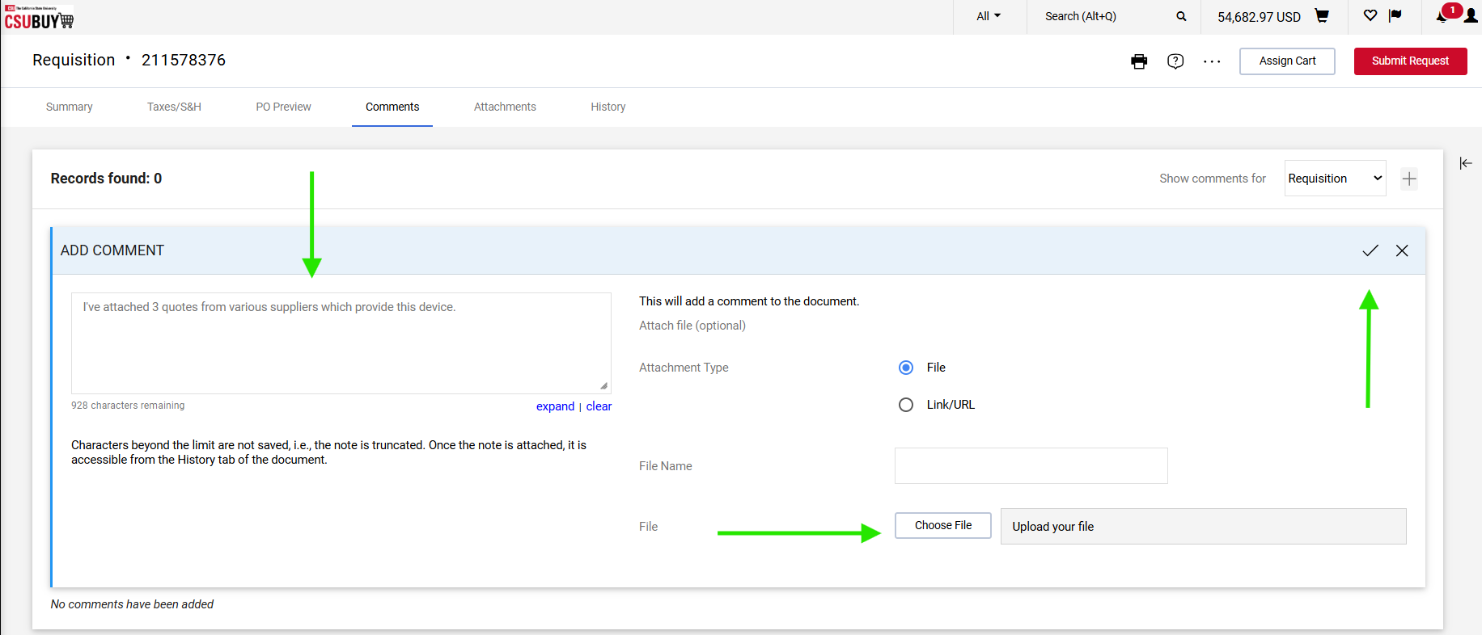

- Use the Attachments tab to upload internal documents for buyer/approver review or external attachments for the supplier.
Click on the Add Internal Attachment link.
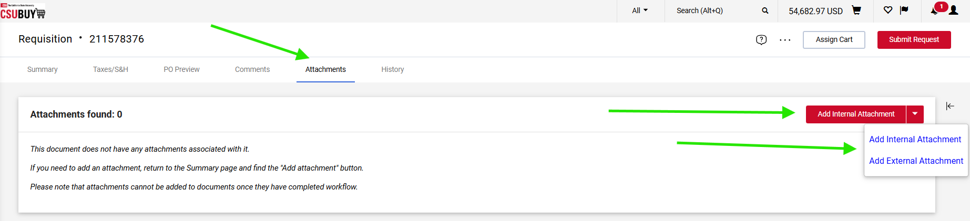

- A new window will appear. Choose either the “File” or “Link” radio button, depending on the type of attachment.
Then, click “Browse” to open your file explorer, select your file, or paste in the URL.
Click “Save Changes.”
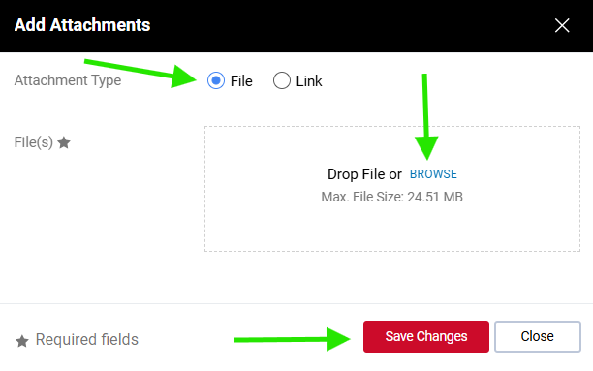

- Under the “Attachments” tab, you should now see the file you just uploaded listed as an attached document.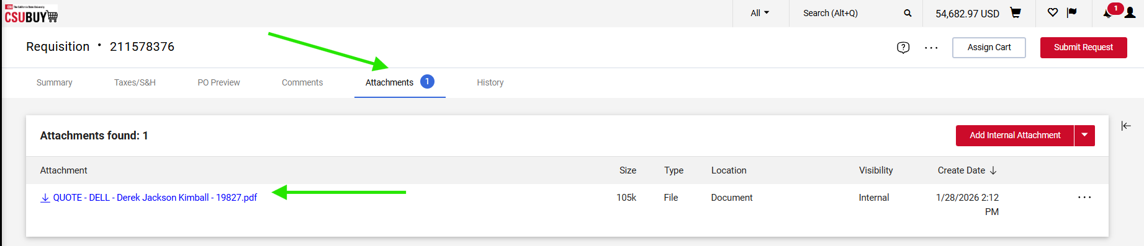

- To remove an attachment, click the ellipsis next to the file and select "Remove."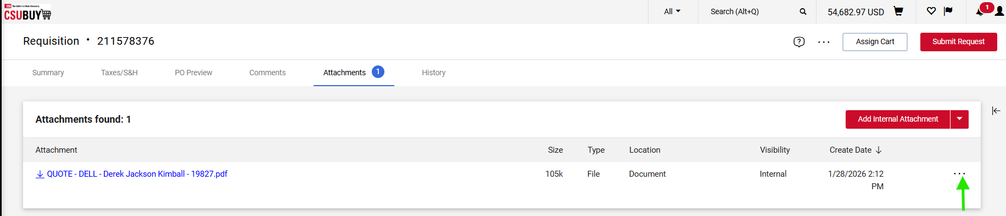

- Click on the “Remove” link in the drop-down menu to remove the attached file from the requisition.
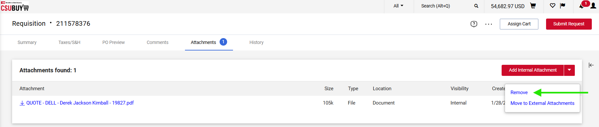

Step 5: Submit and track your requisition
- Click "Submit Request" to complete the requisition process.
+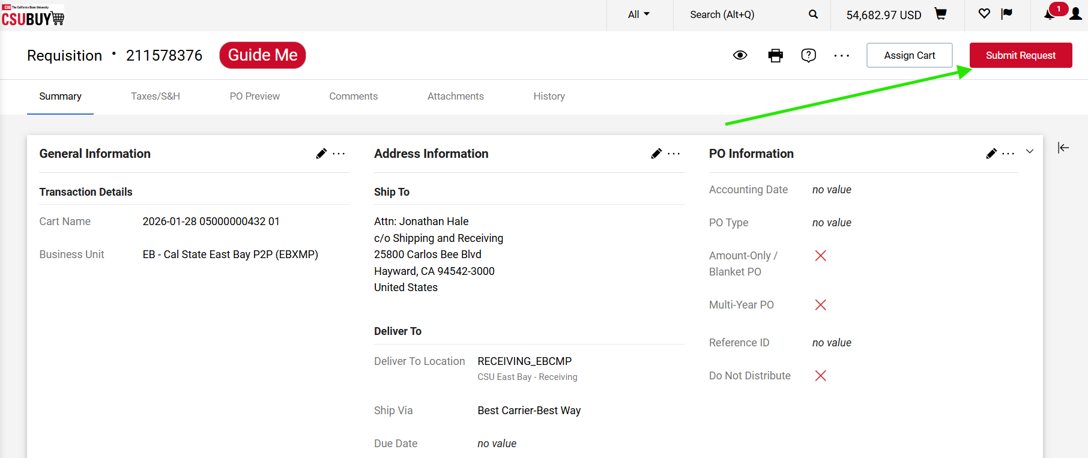
- After you submit the requisition, you’ll receive a confirmation notification like the example below which includes your requisition number.
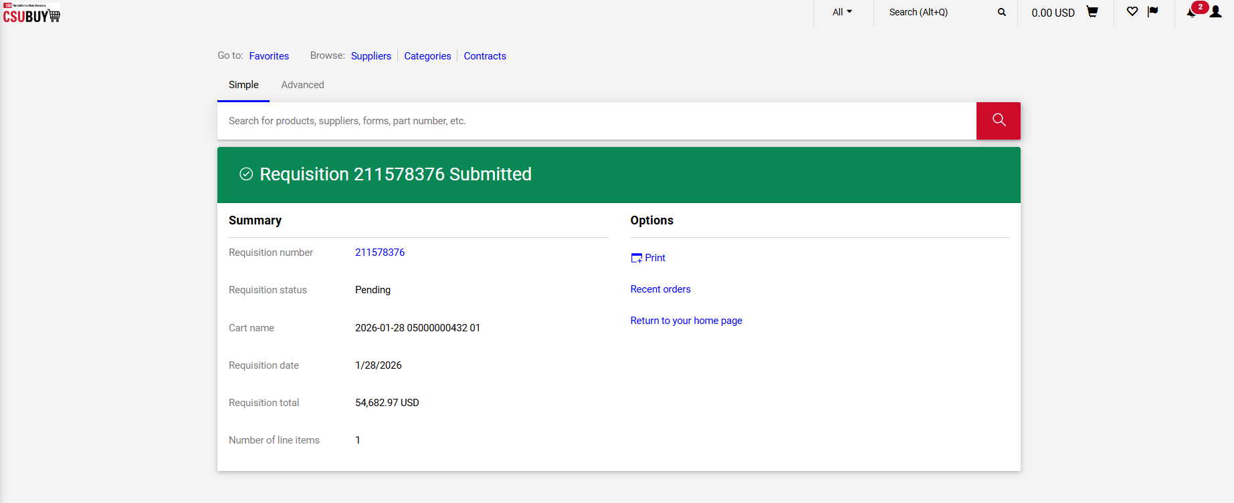

- To check the status of your requisition, click the “Orders” icon in the left navigation pane.
Then select the “Requisitions” link.
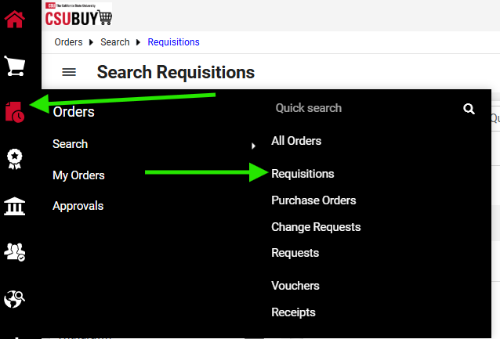

- On the Search Requisitions screen, use the filter in the left navigation pane under “Prepared For” and select your name from the list.
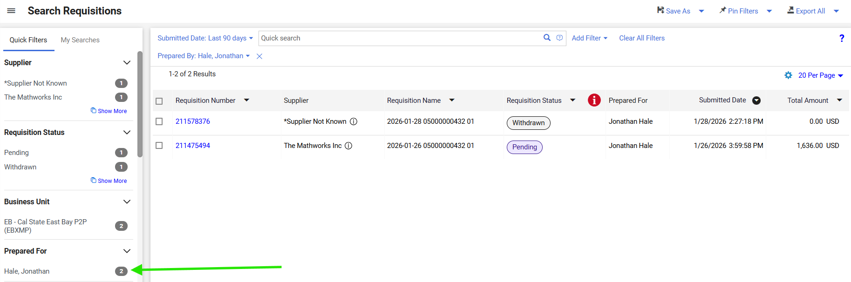

- To view the requisition, click the Requisition Number link from the list of requisitions.
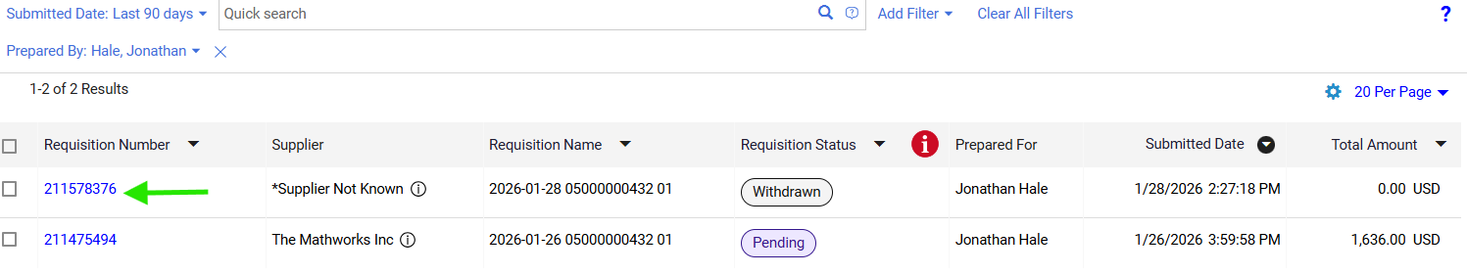

- The summary panel on the right side of the page displays the status and details of your requisition, along with the name of the workflow task approver. If your requisition is not moving forward, email the approver, provide the requisition number, and request that they complete their review.
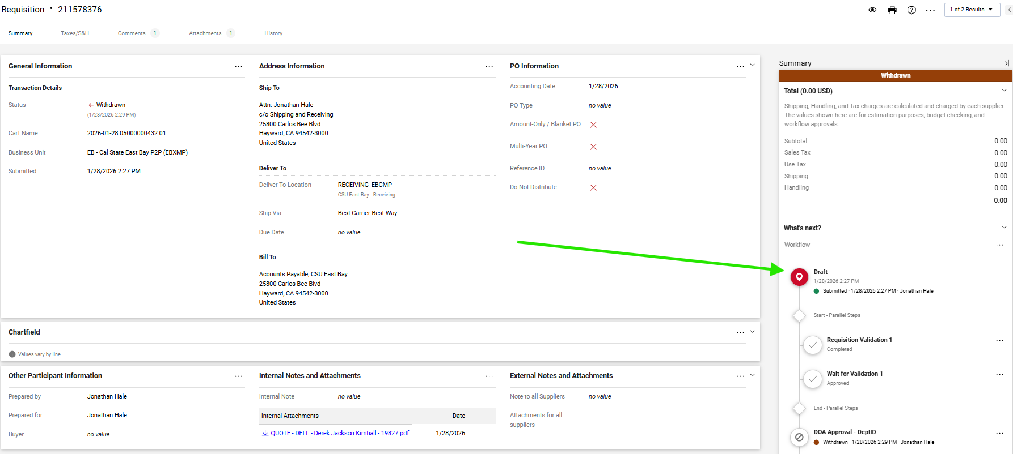
This completes the requisition process.

Troubleshooting and common issues
- Supplier not found: Enter "Supplier Not Known" and continue, then attach a quote or supplier link for review.
- Missing required fields: Confirm Fund, Department ID, and Business Unit are entered before submitting.
- Attachments not saving: After choosing a file, click the check icon to save it, then confirm it appears in the attachments list.
- Wrong delivery location: For tangible items, use the delivery location of your central receiving or office location

FAQ
Q: Who can help if I do not have access to the P2P?
A: To request access to P2P, submit an access request ticket through the SFBRN Service Desk. In the details of your request, indicate that you are requesting P2P access.
https://www.sfbrn.calstate.edu/form/get-help?category=access-identity-management&title=Access+Requests+and+Group+Management

Q: Who can assist if I get stuck?
A: If you have access to P2P and need assistance creating a requisition, visit the Procurement P2P webpage for documentation and guides, or attend Procurement Office Hours.
https://www.sfbrn.calstate.edu/csubuy-p2p

Q: What documents should I attach?
A: Attach all quotes along with any terms and conditions received, plus accessibility and security documentation when applicable (examples: VPAT/ACR, HECVAT). Also provide any email address for direct contacts with the supplier.

Q: How do I check status?
A: Go to Orders > Requisitions, filter by Prepared For, and open the requisition number to view status in the summary panel.

Q: Where do I find my requisition number?
A: After checkout, the system generates a requisition number on the Summary page and in the confirmation message.

Q: What if I do not know the supplier?
A: Enter "Supplier Not Known" in the Supplier field and attach a quote or supplier link.

Q: What if I’m unable to enter the requisition in the P2P system.
A: You will need to request access to the P2P portal in order to create requisitions. You can use the following link to submit an access request ticket with the SFBRN service desk: https://www.sfbrn.calstate.edu/form/get-help?category=access-identity-management&title=Access+Requests+and+Group+Management&utm_source
If you already have access but are still having trouble creating or submitting a requisition, please attend Procurement Office Hours for additional support. https://www.sfbrn.calstate.edu/csubuy-p2p

Q: Why did I get several automated emails?
A: The system sends notifications as the request moves through review, sourcing, shipping, receiving, and payment.

Q: What if the supplier only accepts credit cards? How do I request approval?
A: If a supplier only accepts credit cards, follow the same process for creating a new requisition. When entering the supplier, select “Supplier Not Known.” In the comments section of the requisition, let the Buyer know that the supplier does not accept purchase orders and that you are requesting approval to use a credit card for the purchase. Be sure to attach all required compliance documents and a price quote to the requisition. The Buyer will review your request. If approved, they will reject the requisition and include comments confirming that the purchase is approved for payment by credit card. Once you receive this approval, you may proceed with the credit card purchase.
Important: When reconciling your monthly P-Card report, you must include a copy of the Buyer’s approval with your report. This documentation confirms to the AP Technician that the credit card transaction was reviewed and approved.
Q: How do I request an accessibility or security review only?
A: To request an accessibility or security review of a product, follow the same process used to create a requisition. Enter $0.01 as the line amount. In the comments section of the requisition, indicate that the request is for accessibility or security review only and is not a purchase request. Be sure to attach all required compliance documentation (VPAT and HECVAT).
The requisition and supporting documentation will be reviewed for accessibility and security compliance. Once all required reviews have been completed and approved, the requisition will be closed. When the user is ready to proceed with the purchase, a new requisition will need to be submitted for the actual purchase.

