Requesting IT Software – User Guide

Objective: Give CSU employees the business process for requesting IT software through the CSUBuy (P2P) system.

Scope: To assist customers with purchasing software and submitting the requisition in the P2P.

Requesting IT Software 1
P2P (CSUBuy) IT Software Requisition - Quick Checklist 1
Before you begin: 1
In P2P (Quick Steps) 1
Roles and responsibilities 2
Common terms: 4
Common compliance documents for software: 4
Step 1: Accessing the P2P 5
Step 2: Create the requisition in P2P 6
Step 3 Information Security and Privacy 21
Step 4: Accessibility 25
Supplier Information 30
Step 5: Review or print your requisition 44
Troubleshooting and common issues 56
FAQ 56

P2P (CSUBuy) IT Software Requisition - Quick Checklist

Before you begin:
- Have your item details ready (version, quantity).
- Have a vendor quote.
- Have accessibility/security docs if required (VPAT/ACR, HECVAT).
- Know your chartfields: Fund, Department ID, Account.
- Is this under a current agreement or has there been a previous agreement

In P2P (Quick Steps)
- To access the Procure to Pay portal, open your browser and copy and paste the following link:
  - Click on the link. (https://www.sfbrn.calstate.edu/csubuy-p2p)
- On the Home page, select “IT/Electronics” tile, then click on the “IT Software Request” form.
- Instructions Tab: review the Instruction page, then click the red “NEXT” button (located on the upper right side)
- Suppliers Tab: search for your supplier’s name in the Supplier field, then click “Search”
  - If there are more than one supplier profile listed, select the correct supplier’s name for your request, then click “NEXT”
  - If you do not know the supplier, use “Supplier Not Known.”
- Form Fields Tab:
  - General IT Software Information Tab: complete all the required fields, then click NEXT.
  - Information Security And Privacy Tab: complete all the required fields, then click NEXT.
  - Accessibility Tab: complete all the required fields, then click NEXT.
  - Additional Supplier Information Tab: complete all the required fields, then click NEXT.
  - Cost Details Tab: complete all the required fields, then click NEXT.
    - Unit Price: Total amount of the software if there is more than 1 QTY
    - Quantity: 1
    - Unit of Measure: LOT
    - Product Description: software information and the breakdown of the price. Example: $1,000 per software x 2 QTY = $2,000 total
- Review And Submit Tab: review the information to ensure accuracy. Once reviewed, click on “Add And Go To Cart” button

Shopping Cart Page
- Deliver To Location Box: Enter your delivery location or, for tangible items, type “RECEIVING,” select the delivery location, then click on the “Proceed to Checkout” button.
- Chartfield: Click on the pencil icon (Edit Chartfield line 1 values)
  - Add: Business Unit, Fund, DeptID, and other applicable fields to your chartfield, then click the SAVE button.
- Comments/Attachments Tabs: add communication and supporting documents, if applicable.
- Review your requisition and ensure all fields are correct. Once reviewed, click on the “Submit Request” button.
Save your requisition number and check status under Requisitions.

C x

Roles and responsibilities
Role | What they do
Customer (Requester) | Creates and submits a requisition in P2P. Provides supporting documentation and chartfields.
Delegation of Authority (DOA) approver:  Business Operations  IT Review:  Security Review  Accessibility Review:  Buyer:  Accounts Payable Technician | Reviews the requisition chartfields and then approve the request.  Provides recommendations; helps obtain quotes; supports supplier onboarding; tracks receipt, delivery, and deployment; supports invoice reconciliation.  Subject Matter Experts (SME) reviews IT-related request to confirm that the requested items can be supported by IT staff and comply with campus standards for computing devices.  Evaluates a supplier’s technology, data practices, and safeguards to ensure university information is appropriately protected from unauthorized access, loss, or security threats.  SFBRN Accessibility team member reviews the software request and related compliance documents (VPAT/ACR/WCAG) to determine the impact the requested product will have on campus.  Review requisition details, negotiate terms and conditions, obtain necessary forms or other documentation (if applicable), and source requisitions into purchase orders. Dispatch the purchase order to the supplier.  Review invoices, forwards invoices to department DOA for approval, create a voucher, and issues of payment to supplier.

Common terms:
- CSUBuy/P2P: The Procure-to-Pay system used to create and submit a requisition.
- Requisition: A requisition is a formal request for something, usually goods, services, or resources.
- Requisition number: The number used to track your request in the P2P system.
- Purchase Order: A purchase order is a formal document issued by a buyer to a seller authorizing a purchase of specified goods or services at agreed terms.
- Receipt: A receipt is a written acknowledgment confirming that goods/services have been received.
- Voucher: A voucher is an internal document used to authorize and verify a payment before it is issued.
- Invoice: An invoice is a bill sent by a supplier to Accounts Payable requesting payment for goods or services provided.
- Request for Proposal/RFP: Is a formal business document released to announce a project and invite potential vendors or contractors to submit a competitive bid.

Common compliance documents for software:

- VPAT: Voluntary Product Accessibility Template
A standardized document used by vendors to describe how their product or service supports accessibility standards such as Section 508 of the Rehabilitation Act. It helps organizations evaluate the accessibility compliance of technology products and the impact it will have on their campus.
https://ati.calstate.edu/ati-priority-areas/procurement/vendor-requirements

- ACR: Accessibility Conformance Report.
A completed VPAT form that details a product's conformance with accessibility guidelines. The ACR provides transparency into how accessible a digital product is and identifies any known limitations.
https://ati.calstate.edu/ati-priority-areas/procurement/vendor-requirements#section-552

- HECVAT: Higher Education Community Vendor Assessment Toolkit
A comprehensive questionnaire designed to evaluate the cybersecurity and data privacy practices of third-party vendors that provide services to higher education institutions. It helps institutions make informed decisions about vendor risk.
https://library.educause.edu/resources/2020/4/higher-education-community-vendor-assessment-toolkit

Step 1: Accessing P2P
- Customers can begin their IT software request by navigating to the SFBRN P2P website: https://www.sfbrn.calstate.edu/csubuy-p2p

- Click the CSUBuy Login Button. Customers will login using their NETID and password.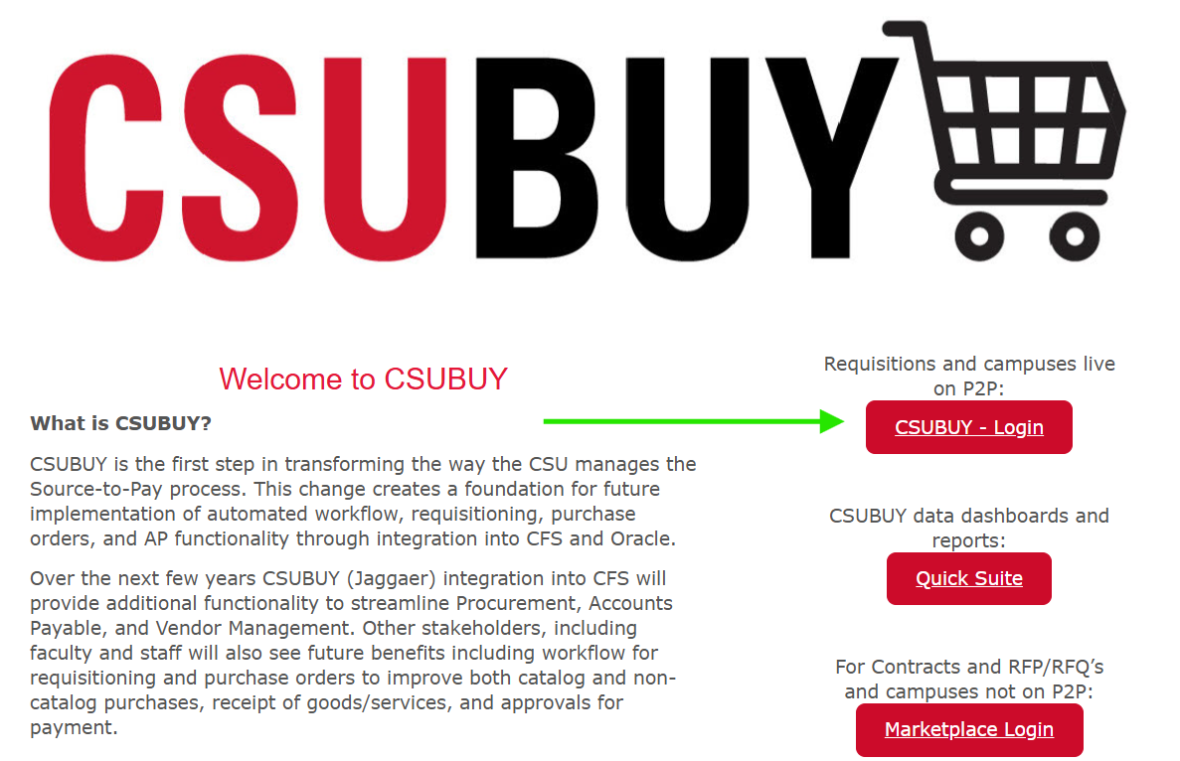

Step 2: Create the requisition in P2P
- After you log in, you will be directed to the CSUBuy Portal Shopping Home Page.
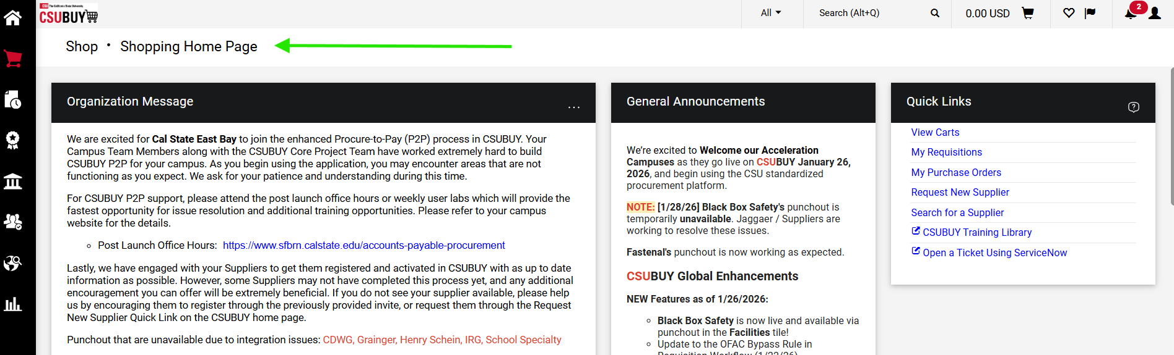

If you do not see the Shopping Home Page, click the shopping cart icon in the left-hand navigation panel.

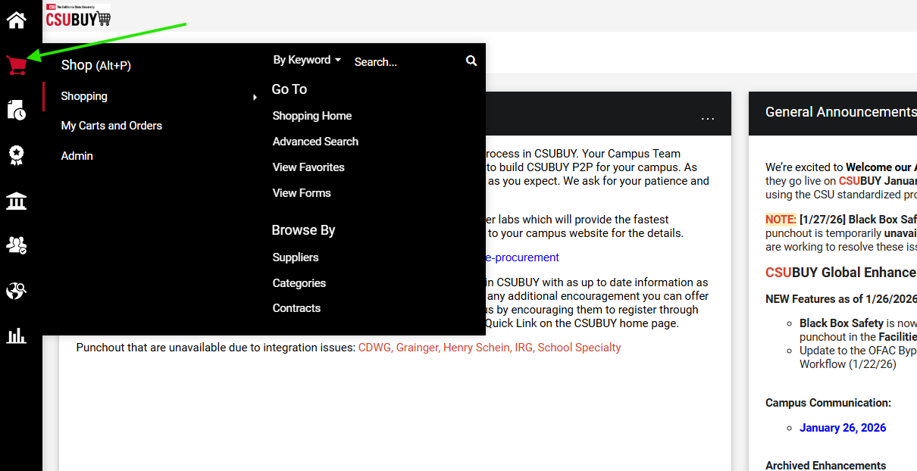
- Scroll down and select the "IT / Electronics" catalog tile.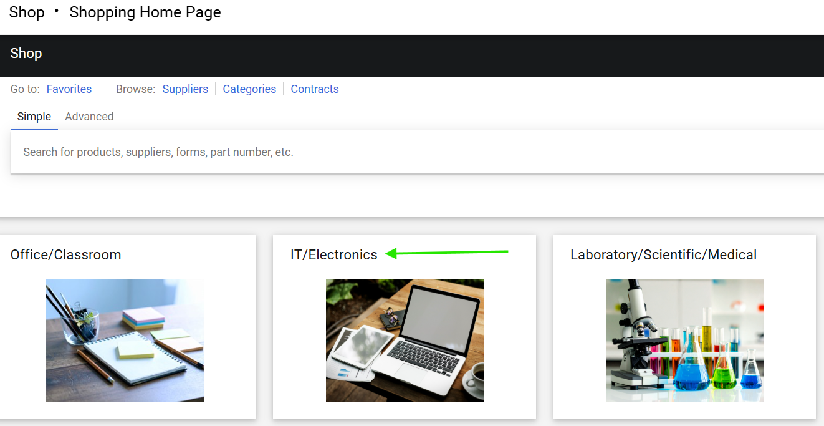
- Select the "IT software Request" catalog item.
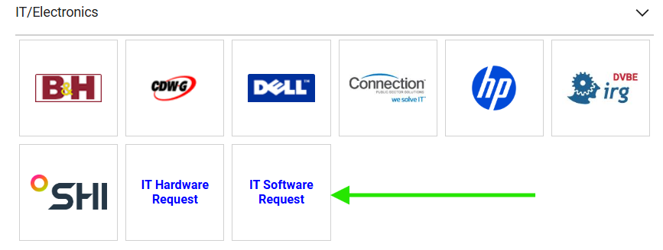

- Review the instructions and click "Next" at the top of the screen.
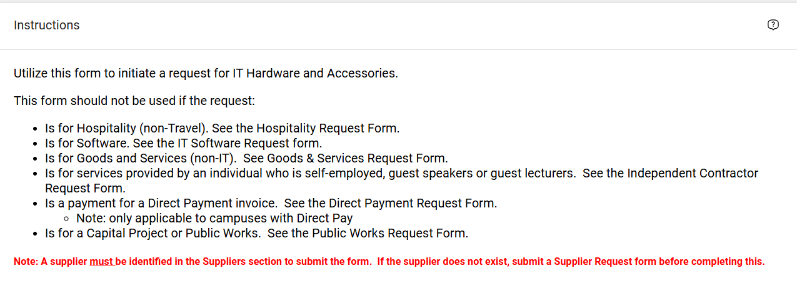

- In the Supplier field, enter the supplier’s name, and click search.
- Check the supplier's name in the results and click “Select” to apply the supplier to the cart.
- If the supplier is unknown, enter “Supplier Not Known,” click Search, and select the “Supplier Not Known” option from the list.

Q: When should we use “Supplier Not Known”?
A: Select “Supplier Not Known” when creating a requisition in the following situations:
- $0 requisition for an RFP: When a supplier has not yet been selected and the requisition is being submitted as part of the RFP process.
- $0 requisition for IT review/approval only: When the requisition is being submitted for an IT, accessibility, or security review and is not yet a purchase request.
- Buyer’s P-Card purchase: When requesting that the Buyer make an approved purchase using their P-Card.
Important: “Supplier Not Known” should only be used for approved situations where the actual supplier cannot or should not be selected when the requisition is created.

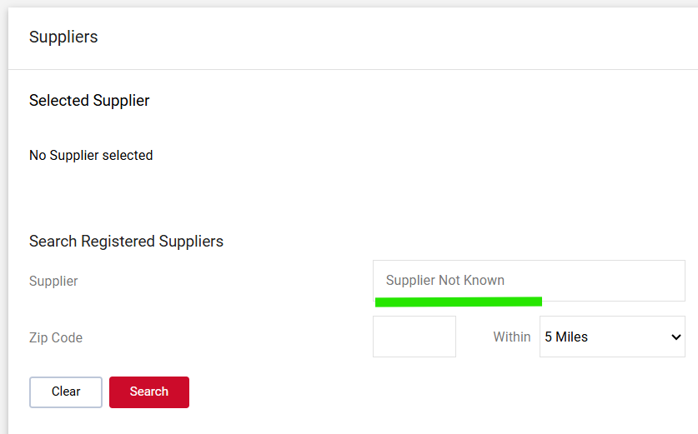

- With "Supplier Not Known" selected, click "Next" at the top right.

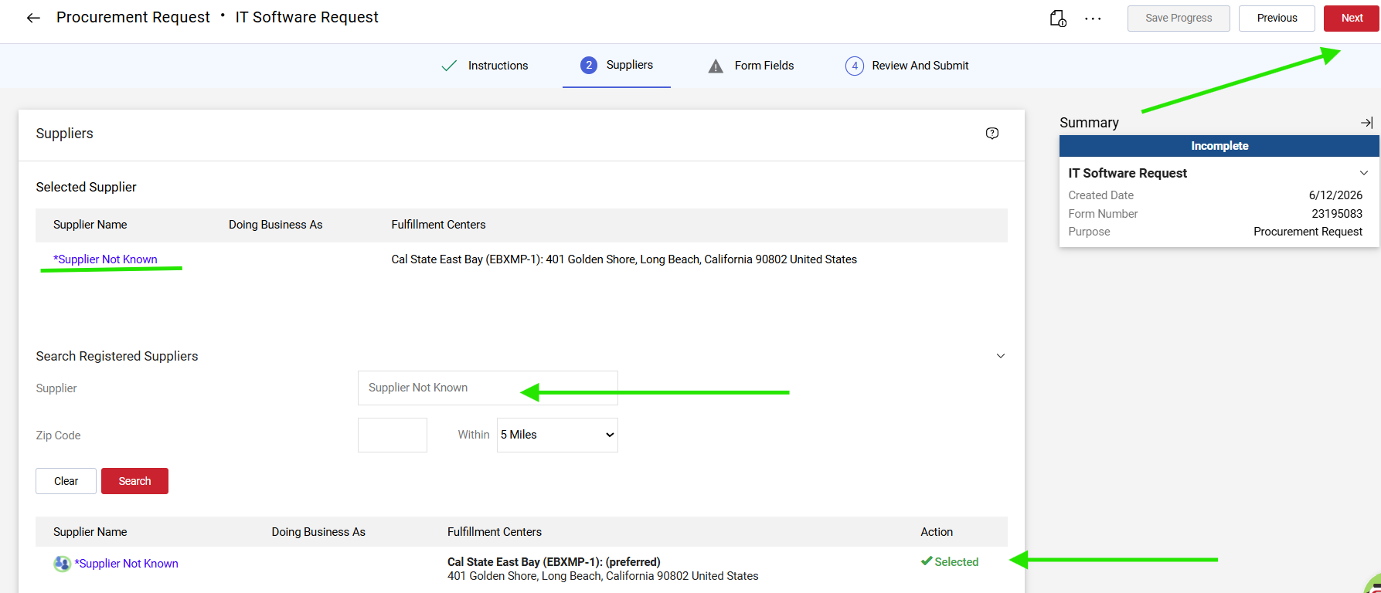

- Complete the required fields on the "Products or Services Details" page.

  - Request Type
    - Example: New purchase, renewal, upgrade, replacement, subscription, etc.

  - Name of IT Product
    - Example: Microsoft 365, Adobe Acrobat Pro, Slack, Dell laptop, ServiceNow module, etc.

  - Link to product website:
    - Copy and paste the URL to the item’s webpage.

  - IT Request Number/ITPR
    - Enter the ITPR provided by your campus. If you have not been provided with an ITPR, select no.
(ITPR applies to SFSU only)

  - IT Product Type or Service Type:
    - Cloud Services: Software or infrastructure hosted by the vendor and accessed over the internet rather than installed on campus servers or devices. Includes Software-as-a-Service (SaaS) applications, hosted platforms, and cloud storage or computing (e.g., AWS, Azure, Google Cloud).

    - Maintenance: Ongoing support, updates, patches, or technical assistance for a product the campus already owns or licenses. Includes annual support renewals, warranty extensions, and service or maintenance contracts.

    - Software: A licensed application or program installed and run on campus-owned devices or servers, whether purchased outright (perpetual license) or licensed for a term. Includes desktop and on-premises applications.

    - Website: Products or services used to build, host, or maintain a website or other web-based presence. Includes web hosting, domain registration, website design or development, and content management systems (CMS).

    - Other: Any IT product or service that does not fit the categories above. Select this option and describe the product or service in the request details.
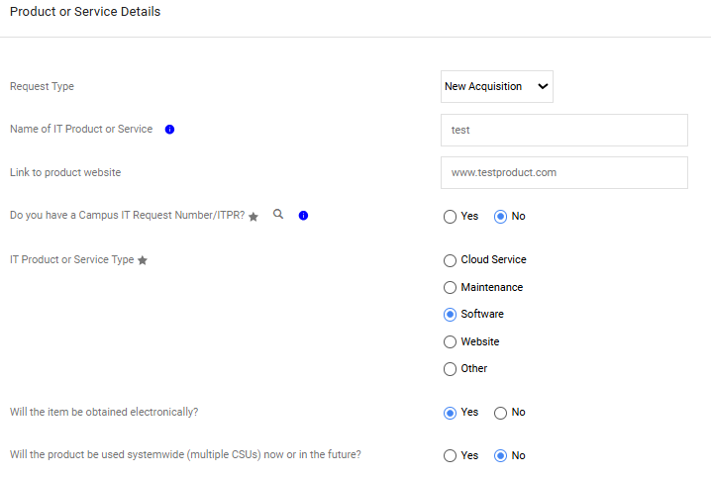

  - Will the item be obtained electronically?
    - Yes, if the product will be provided via download or email.
    - No, if the supplier ships a USB drive, dongle, or any other tangible media.

  - Will the product be used systemwide (multiple CSUs) now or in the future?
    - Yes, if the product is used by more than one campus within the CSU.
    - No, if the product will only be used by one campus.

  - Who will be using the product?
    - Select Yes, if CSU staff members will directly interact with this product.
    - Select Yes, if CSU students will directly interact with this product.
    - Select Yes, if CSU faculty members will directly interact with this product.
    - Select Yes, if members of the public will directly interact with this product.

  - Approximate number of users:
    - Select a number from the drop-down menu, listing the number of users who use the product.

  - Provide the details and/or justification of the request
    - Explain: What it is, what it does, why it is needed, who will be using it and how they will use it (intended use by each group).
      - ️ If your response is longer than 2,000 characters write: “See Attached”, and then upload full justification as a separate document.

  - Estimated Dollar Value (Annually)
    - Enter the total amount of this request.

  - Agreement number of years/ term:
    - Enter the number of years this product will be used.

  - Requesting Department
    - Enter the name of the requesting department.

  - Form Completed By
    - Enter your name or the name of the person completing the requisition process.

  - Will IT staff be needed to set up or support this software?
    - Yes, if you will need a technician from IT to help install, activate, or support the product being requested.
    - No, if you can install, activate, and support the product yourself.

  - Does this support Single Sign On?
    - Yes, if the user can login using their CSU credentials.
    - No, if the user is to login using email address, username and password,

  - Does this request involve an AI tool or AI capability (e.g., generative AI, API access, AI features in software)?
    - Yes, the product uses or includes AI capabilities, such as generative AI, machine-learning features, AI-driven automation or analytics, or access to AI models through an API.
    - No, the product does not include any AI capabilities.
    - If Yes, Describe the AI use / capability. Briefly explain how the product uses AI: what the AI feature does, how it will be used, and what data (if any) it processes.

  - Is the software requested subscription based?
    - Yes, select the type of subscription. (Monthly, Yearly, Multi-year, Other.
    - No, if the software is licensed to the campus and renewed one-time annually.

  - Does the licensing model support a separate Development, Test, and Production environment model without additional costs for Dev/Test environment licenses?
    - Yes, no additional licenses or fees are required to use separate Development, Test, and Production environments.
    - No, A single license or fee includes access to all Development, Test, and Production environments.
    - Not Applicable: The product does not provide separate Development, Test, and Production environments.

  - Are you requesting the goods or services from a sole source or sole brand?
    - No, Multiple suppliers can provide the requested goods or services.
    - Yes, Sole Source: request is for one product and that product can only be supplied by one supplier.
    - Yes, Sole Brand: Sole Brand is only one product but it can be supplied by multiple distributors.

Click the next button in the upper right corner when you’re finished.

Step 3 Information Security and Privacy
- Will the product or service interact with any campus application or system?
  - Yes, the product connects to, integrates with, or exchanges data with an existing campus application or system (for example, single sign-on, the student information system, HR, or Active Directory).
  - No, the product runs independently and does not connect to or exchange data with any campus application or system.

- In which country is the vendor headquartered?
  - List the name of the country. Can be found on the “Contact us” page of the suppliers website.

- Will the product or service collect, transport, store, analyze, or process campus data?
  - Yes, the product handles campus data, including collecting it from users or systems, transmitting it, storing it, or performing analysis or processing on it.
  - No, the product does not touch campus data at any point; it neither receives, stores, nor processes any data belonging to the campus.

- If yes, for which CSU population? Check all that apply:
  - Student Applicants
  - Student
  - Job applicant
  - Employee
  - Alumni
  - Donor
  - Other – Please specify.

- Where is the Data Stored and Processed? Please note additional contractual concerns arise when data is stored or processed outside the US, particularly the EU, China (including Hong Kong and Macau), Russia, Iran, North Korea, Cuba, and Venezuela.

- Ask the vendor where your data will be stored and handled, including backups, and provide the country or location. This information is usually available from the vendor or in the contract or Data Processing Agreement (DPA). CSU requires this information because sensitive data may not be allowed to be stored or processed outside the United States.

- What is the highest (e.g. most sensitive) level of data this product/service will handle?
  - Level 1 Confidential: The most sensitive data, where unauthorized disclosure could cause significant harm to individuals or the university (e.g., Social Security numbers, financial account numbers, health records, protected personal information).
  - Level 2 Internal Use: Data that is not public and must be protected, but is less sensitive than Level 1 (e.g., internal communications, non-public operational or employee information).
  - Level 3 General / Public: Data that may be released to the public with little or no restriction (e.g., published directory information, public-facing materials).

- What type of activity will this solution or vendor support? (select all that apply)
  - Processing the data: the product performs operations on campus data, such as calculating, transforming, organizing, or otherwise working with it.
  - Collecting the data: the product gathers or captures campus data from users, systems, or other sources.
  - Selling data to a 3rd party: the vendor sells campus data to an outside party.
  - Sharing data to a 3rd party for cross-context behavioral advertising: the vendor shares campus data with an outside party to target advertising across different sites or services.
  - Other (please specify): any other data activity not listed; describe it in the space provided.
  - None: the product does not perform any of the activities above.

- What data subject types will have data included in this solution/service?
  - Student: individuals currently or previously enrolled at the campus.
  - Job applicant: individuals who have applied for employment but are not employed by the campus.
  - Employee: current or former faculty and staff.
  - Alumni: individuals who have graduated from or previously attended the campus.
  - Donor: individuals or entities that have given, or are solicited to give, to the campus.
  - Other: Please specify: any data subject type not listed above; describe it in the space provided.

- What is the legal basis for processing this data?
  - CSU tries to limit how many systems contain university data to reduce the risk of data being exposed, stolen, or affected by a security or ransomware incidents. The point of this question is to understand a justifiable reason for why the supplier is holding this data.

- Please provide rationale for legal basis.
  - Explain why the supplier needs this information and what they are going to do with it.

- Do users require access from off-campus locations?
  - Yes, users will connect from outside the campus network (home, travel, etc.).
  - No, the product is only used on campus.

- Is the product or service hosted off-site (outsourced or cloud-hosted)?
  - Yes, the software runs on a vendor's or third-party servers (like AWS or Azure), meaning the campus doesn't directly control the infrastructure or data storage.
  - No, the product is hosted on campus-owned servers.

- Does the product act as a server or accept inbound network traffic?
  - Yes, the product opens a network connection to receive requests from other systems or users.
  - No, the product only sends outbound requests and does not expose an open network entry point.

- Will the software require data from any campus systems or applications?
  - Yes, the product needs to connect to or pull data from existing campus systems (like HR, student records, or Active Directory).
  - No, the product operates independently without accessing any campus data or systems.

- Does the solution support Multi-Factor Authentication (MFA)?
  - Yes, the product can require users to verify their identity with a second factor beyond a password.
  - No, the product uses password-only login.

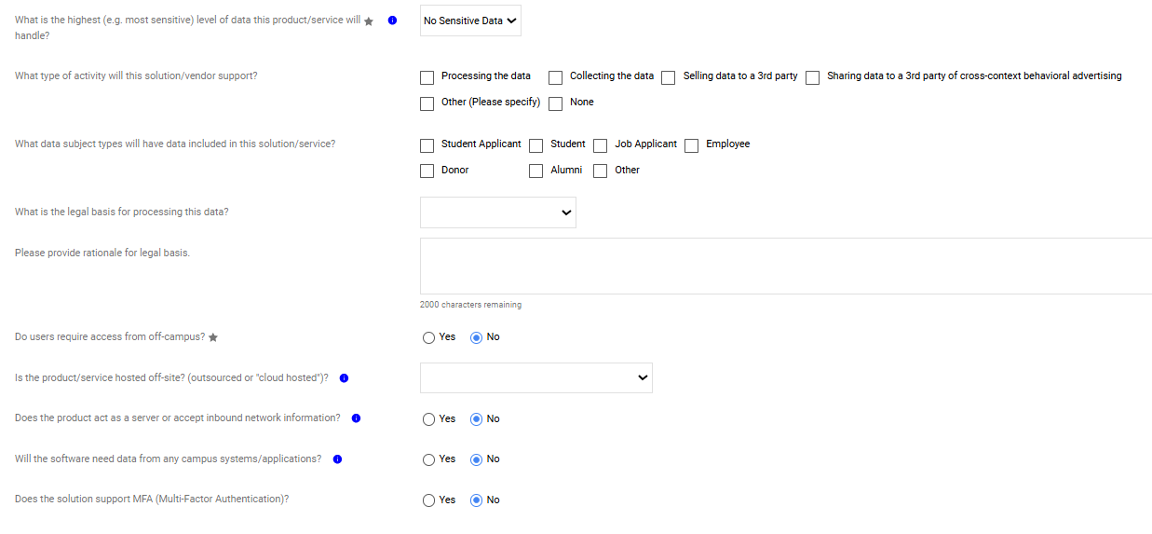

Step 4: Accessibility
- Provide a link or upload accessibility conformance documentation; VPAT, accessibility statement.
  - Upload files from your desktop for the Approver to review.

- Is the accessibility conformance documentation provided dated within the last 12 months?
  - Yes, the accessibility review was completed within the last 12 months.
  - No, the supplier will be contacted, and the current VPAT/ACR compliance document will be requested.

- Is there a dedicated accessibility officer (at the company of the product you are purchasing) or contact method for accessibility related problems?
  - Yes, if you have a direct contact email address. This information can be located on the VPAT/ACR document under the product details section.
  - No,

- How many ways can users access this software or service? Select all the platforms it supports.
  - Desktop application
  - Website
  - iOS mobile app
  - Android mobile app
  - Other

- Does the application provide different views based on user roles? (e.g., admin, end-user)
For example, are there different screens or features shown depending on the role of the user?
  - Yes: the application displays different features, menus, or data depending on whether the user is an administrator, standard user, or another assigned role.
  - No: all users see the same interface and have access to the same features, regardless of who they are.

- Is this purchase on Chancellor's Office MEA? A Master Enabling Agreement (MEA) is a systemwide contract established by the CSU Office of the Chancellor, where the key terms, services, and pricing are predefined. Once an MEA is in place, all campuses can utilize it, they just issue a service order or participate through their own campus agreements to access the offerings.

ATS Master Enabling Agreements and Contracts

  - Yes, this purchase is part of a CSU Master Enabling Agreement (MEA)
  - No, this purchase is not part of an existing CSU MEA.

- Will this be utilized directly in the delivery of course instruction to students?
  - Yes: the product will be used as part of teaching or coursework that students interact with (for example, in a class, lab, or assignment).
No: the product is not used in delivering instruction to students.

- Will this be required to complete essential functions for a job?
  - Yes: an employee must use this product to perform the core duties of their position.
No: the product is optional or supplemental and is not required to perform essential job functions.

- Is this product public-facing?
  - Yes: the product is accessed or used by members of the public, not only campus staff, faculty, or students.
No: the product is used only internally by the campus community.

- Click the Next button in the upper right to continue to the next screen

Note: Depending on the type of software product you’ve requested, you may receive a supplemental questionnaire from the Accessibility team to help them review the product.

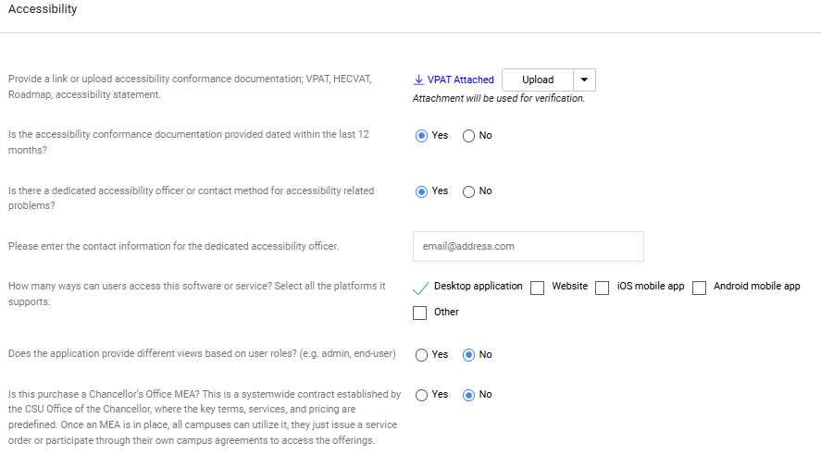

- Click the next button at the upper right corner to continue to the next screen.

Supplier Information

Provide the supplier website for the product or service

- Supplier Contact Name
- Supplier Contact Department/Title
- Supplier Contact Email
- Supplier Contact Phone
- Click the next button in the upper right corner to continue to the next screen.

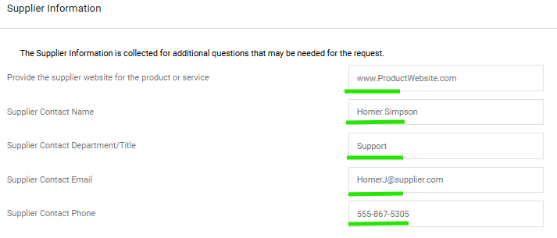

- On the "IT Software Cost Details" page, check the Yes button upload the attachments. (e.g., Terms and Conditions, Insurance Certificates, Statement/Scope of Work (SOW), VPATs, HECVATS, proposals, quotes etc.).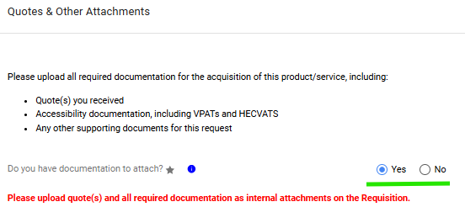

- Enter the Unit Price, Quantity, and Unit of Measure, and Product Description.
  - Unit Price: The cost of a single unit of the product or service, excluding taxes, shipping, and any additional fees.
  - Quantity: The total number of units of the product or service being purchased.
  - Unit of Measure: The standard unit used to quantify the product or service, select “Lot” from the values. Product Description: Summary of the product or service, including its key features, specifications, term dates, or purpose.

  - Click the next button in the upper right corner to continue to the next screen.

- 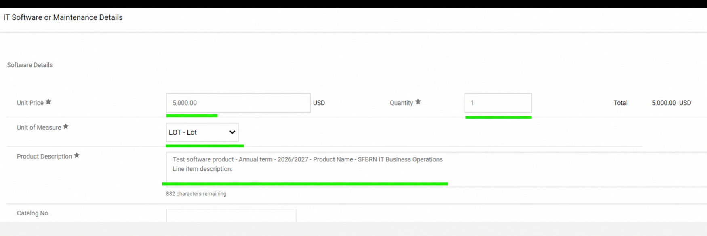

- On the "Review and Submit" page, verify supplier and form details.
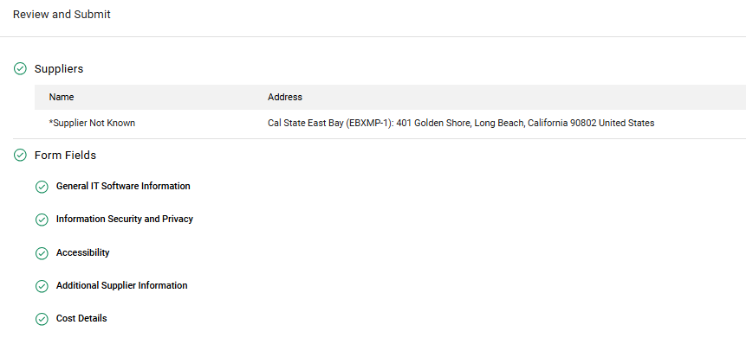

- Click "Add and Go to Cart."



- If you have additional line items to add to the requisition, click the dropdown arrow and select “Save to Cart and Add Another”.
(In this example, we’ll add a single line to the requisition.)
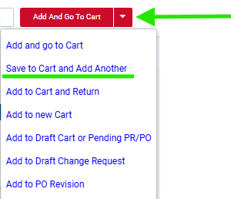

- Click on "Add and Go to Cart” to continue to the next screen.


- On the Requisition page, enter a Cart Name. To make requisitions easier to locate in the future, use a standardized naming convention.
  - Recommended format: Supplier Name – Product Name – Fiscal Year
  - Example: Acme Corp – Laptop Computers – FY2026/27

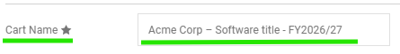

- Select "RECEIVING_CMP" as the delivery location.
Note: This value may vary depending on your campus. Be sure to select the appropriate receiving location for your campus.

- In the “Item details” section at the bottom of the screen, select “No” in the Receiving Required drop-down. Check the “Taxable” box if sales tax should be applied to this purchase.

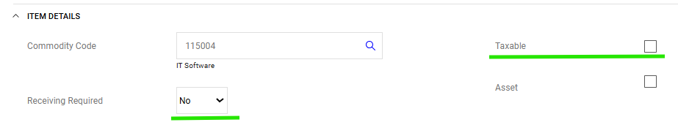

- Click on the “Proceed to Checkout” button at the top right corner of the screen.

- The system will generate a requisition number which will appear in the upper left corner of the screen. You will also see 6 tabs underneath the requisition number. (Summary, Taxes/S&H, PO Preview, Comments, Attachments, and History.)
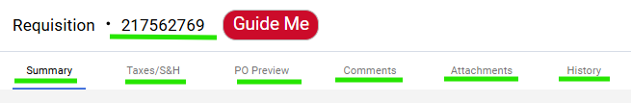

- Under the “PO Information” tab, click on the pencil icon in the upper right corner of the section to edit the fields.
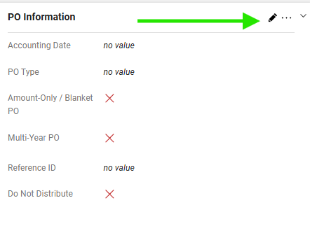
- In the “Edit PO Information” pop up window, select the calendar icon next to the “Accounting Date” field.
Note: the accounting date should be left blank

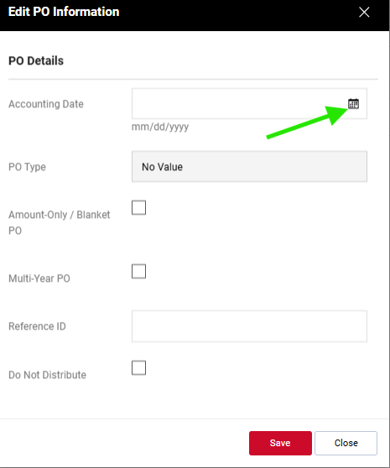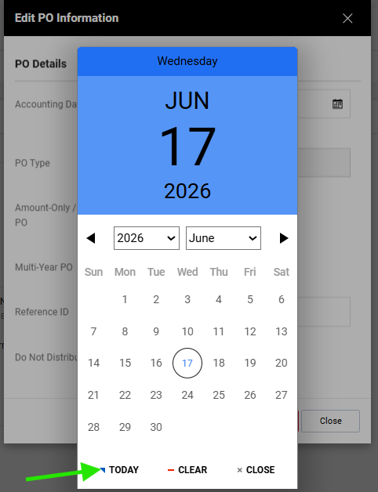

- Enter the request reference in the “Reference ID” field.
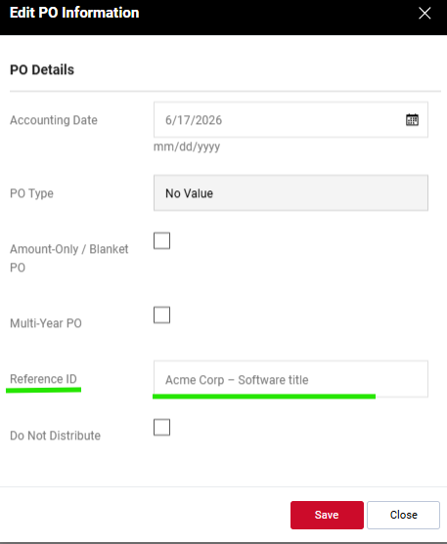
- Next, scroll down and click on the pencil icon under the “Internal Notes and Attachments” section.

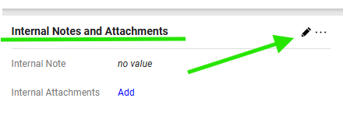

- In the internal notes and attachments window insert any order details you would like to buyer to see. Click Save.

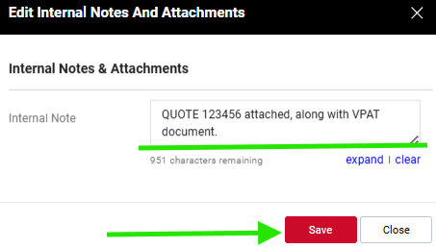

- In the same section, internal notes and attachments click on the “Add” button.

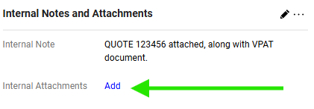

- In the Add Attachments window, select File if you have a document to attach, or link if have a website URL for the item.
- Click the “Browse” icon to search for the file you want to upload, then click “Save changes”

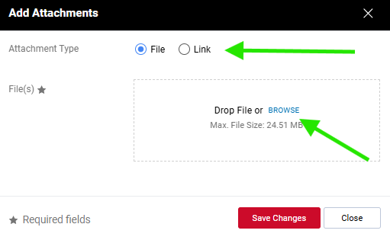

- Scroll down to the bottom of the page and review the “Item Details” and “Chartfields” sections.
Click on the pencil icon to the right of the screen to edit values.

- Enter values in the following fields:
- Required: Business Unit, Fund, Department ID
- Optional: Program, Class, and Project codes
Click Save.

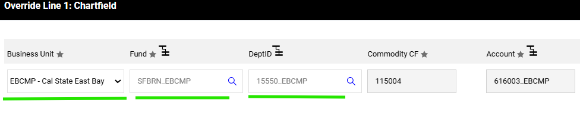

Step 5: Review or print your requisition

- If you would like to review or print a copy of the requisition, click the printer icon in the top right corner of the page.
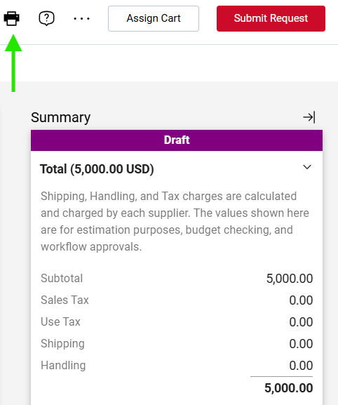

- After clicking the printer icon, you will be redirected to a new screen displaying a copy of your requisition.
Click the “Print” button in the top right corner of the page to print or save the document.
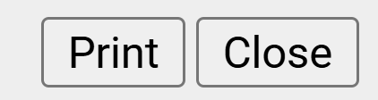

- In the print dialog box, select “Save as PDF” to save the requisition to your computer.
- Click “Save”.

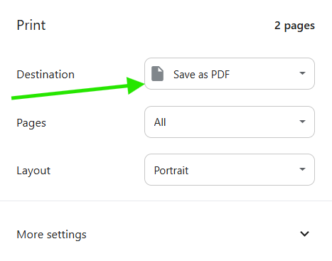

- Select a destination folder.
Enter a file name.
Click Save.
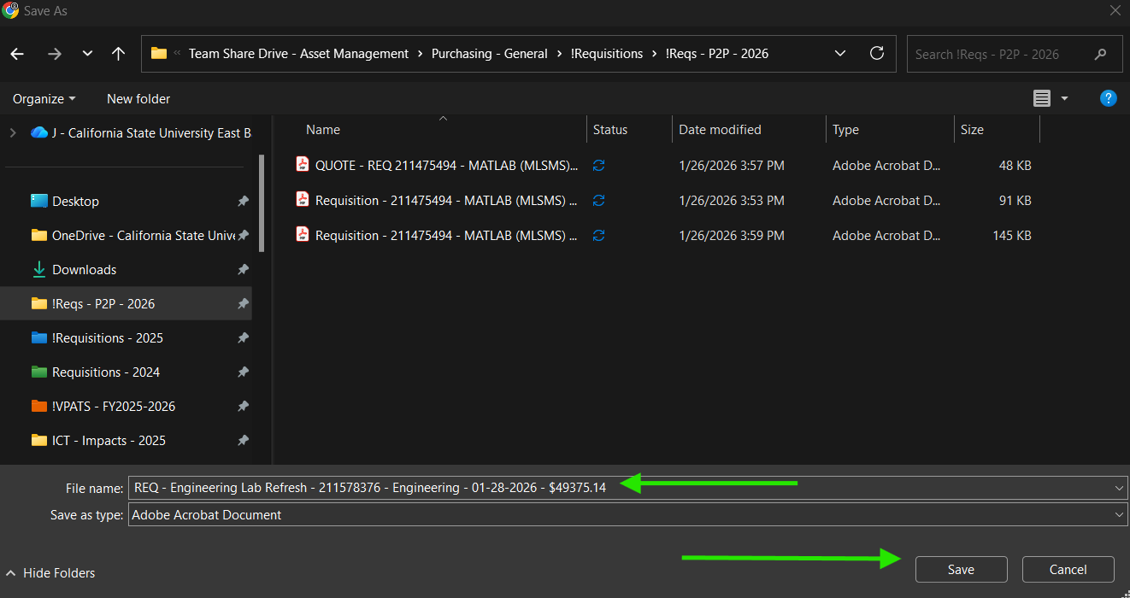
- The print dialogue screen will close, and you will be returned to the requisition print summary page.
Click the "Close" button at the top right corner of the screen to exit this page.

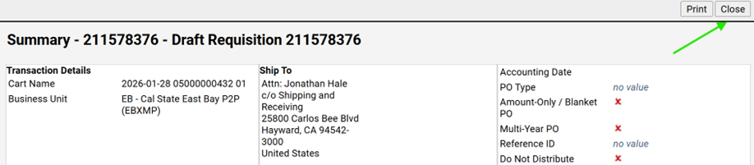

- Verify that your document appears on the Attachments tab. If you do not see the uploaded file, return to the Summary tab and use the Internal Notes and Attachments link to upload the document again. To remove an attachment, click the ellipsis next to the file and select Remove.

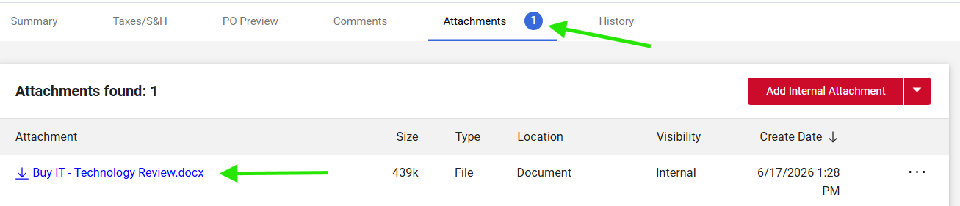
- Click on the “Remove” link in the drop-down menu to remove the attached file from the requisition.

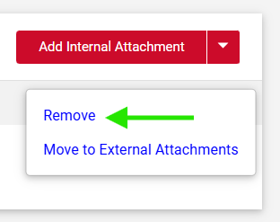
Step 6: Submit and track your requisition
- Click "Submit Request" to complete the requisition process.
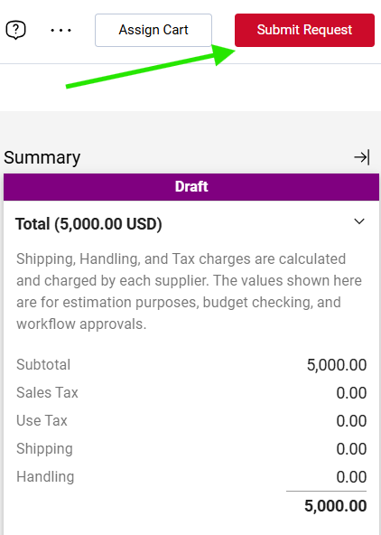

- After you submit the requisition, you’ll receive a confirmation notification like the example below which includes your requisition number.
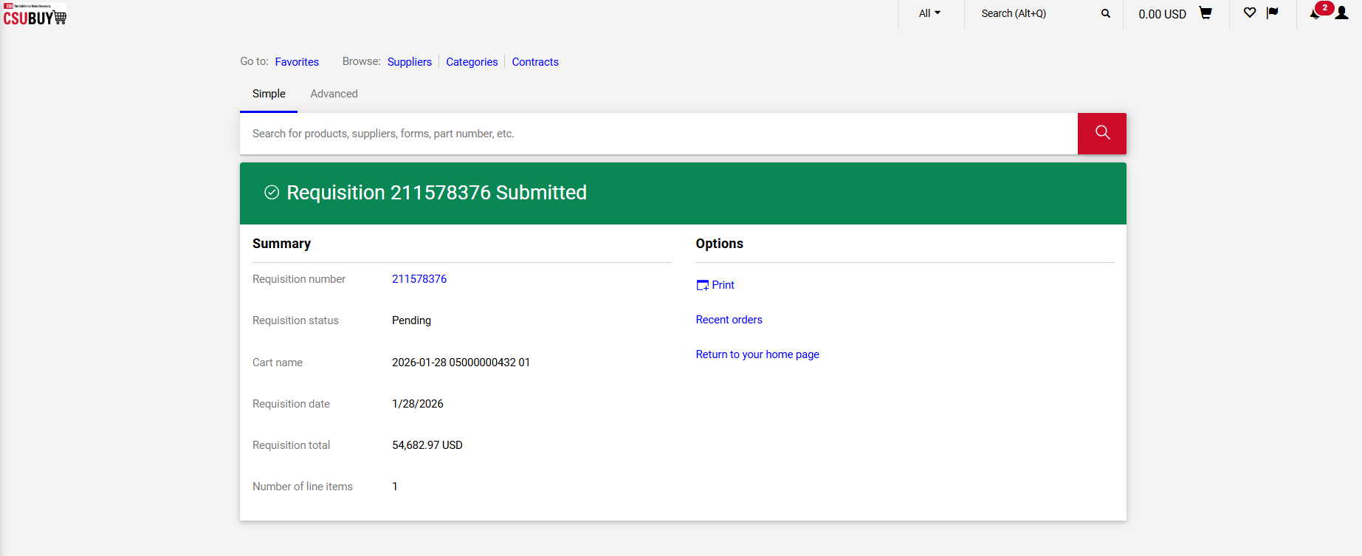

- To check the status of your requisition after submitting, click the “Orders” icon in the left navigation pane.
Then select the “Requisitions” link.
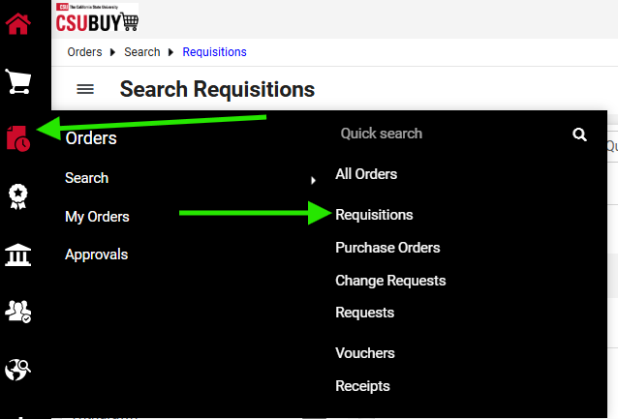

- On the Search Requisitions page, enter the requisition number in the search field at the top of the screen and click Search.
To view all requisitions you submitted, use the filter in the left navigation pane. Under Prepared For, select your name from the list to display all requisitions associated with you.
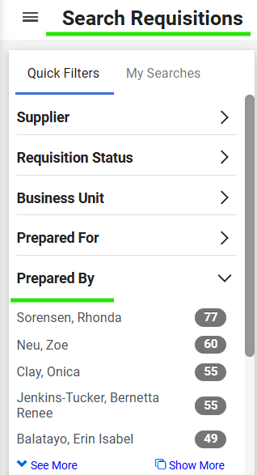

- To view the requisition, click the Requisition Number link from the list of requisitions.
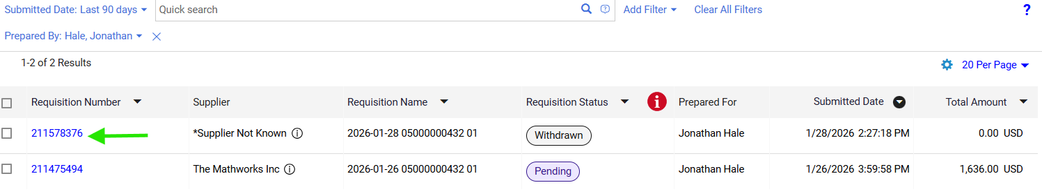

- The Summary panel on the right side of the page provides an overview of your requisition, including its status, key details, and the active workflow task. To view the approval workflow and identify the individual currently reviewing your request, click the workflow task name to expand the approval details.

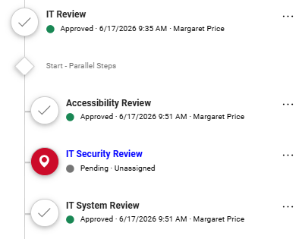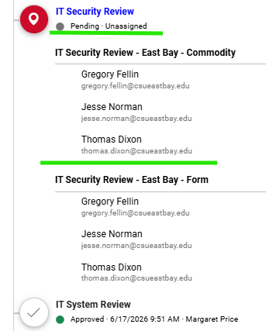

- If your request has not been approved, check the Comments tab to determine the reason. Buyers, Central Receiving staff, Accounts Payable staff, and approvers use this section to provide updates, request additional information, and document actions taken during the review process.

This completes the requisition process.

Troubleshooting and common issues
• Supplier not found: Enter "Supplier Not Known" and continue, then attach a quote or supplier link for review.
• Missing required fields: Confirm Fund, Department ID, and Business Unit are entered before submitting.
• Wrong delivery location: For tangible items, use the delivery location of your central receiving or office location
• Attachments not saving: After choosing a file, click the check icon to save it, then confirm it appears in the attachments list.

FAQ
Q: Who can help if I do not have access to the P2P?
A: To request access to P2P, submit an access request ticket through the SFBRN Service Desk. In the details of your request, indicate that you are requesting P2P access.
https://www.sfbrn.calstate.edu/form/get-help?category=access-identity-management&title=Access+Requests+and+Group+Management

Q: Who can assist if I get stuck?
A: If you have access to P2P and need assistance creating a requisition, visit the Procurement P2P webpage for documentation and guides, or attend Procurement Office Hours.
https://www.sfbrn.calstate.edu/csubuy-p2p

Q: What documents should I attach?
A: Attach all price quotes received along with any terms and conditions, plus accessibility and security documentation when applicable (examples: VPAT/ACR, HECVAT). Also provide any email address for direct contacts with the supplier.

Q: How do I check status?
A: Go to Orders > Requisitions, filter by Prepared For, and open the requisition number to view status in the summary panel.

Q: Where do I find my requisition number?
A: After checkout, the system generates a requisition number on the Summary page and in the confirmation message.

Q: What if I do not know the supplier?
A: Enter "Supplier Not Known" in the Supplier field and attach a quote or supplier link.

Q: What if I’m unable to enter the requisition in the P2P system.
A: You will first need to request access to the P2P portal in order to create requisitions. You can use the following link to submit an access request ticket with the SFBRN service desk: https://www.sfbrn.calstate.edu/form/get-help?category=access-identity-management&title=Access+Requests+and+Group+Management&utm_source
If you already have access but are still having trouble creating or submitting a requisition, please attend Procurement Office Hours for additional support. https://www.sfbrn.calstate.edu/csubuy-p2p

Q: Why did I get several automated emails?
A: The system sends notifications as the request moves through review, sourcing, shipping, receiving, and payment.

Q: What if the supplier only accepts credit cards? How do I request approval?
A: If a supplier only accepts credit cards, follow the same process for creating a new requisition. When entering the supplier, select “Supplier Not Known.” In the comments section of the requisition, let the Buyer know that the supplier does not accept purchase orders and that you are requesting approval to use a credit card for the purchase. Be sure to attach all required compliance documents and a price quote to the requisition. The Buyer will review your request. If approved, they will reject the requisition and include comments confirming that the purchase is approved for payment by credit card. Once you receive this approval, you may proceed with the credit card purchase.
Important: When reconciling your monthly P-Card report, you must include a copy of the Buyer’s approval with your report. This documentation confirms to the AP Technician that the credit card transaction was reviewed and approved.

Q: How do I request accessibility or security reviews only?
A: To request an accessibility or security review of a product, follow the same process used to create a requisition. Enter $0.01 as the line amount. In the comments section of the requisition, indicate that the request is for accessibility or security review only and is not a purchase request. Be sure to attach all required compliance documentation (VPAT and HECVAT).
The requisition and supporting documentation will be reviewed for accessibility and security compliance. Once all required reviews have been completed and approved, the requisition will be closed. When the user is ready to proceed with the purchase, a new requisition will need to be submitted for the actual purchase.

